

Commercial Lines

Workflows & Procedures

*For*

Acrisure Mid-Atlantic Partners Insurance Services, LLC



v4.29.25

## Version Updates

|  |
| --- |
| * Updated: Audit Workflow expanded with attachment details and correct download activity code * Added: Importing and Exporting of Risks in Epic |

# How to Use this Document

|  |
| --- |
| This document contains valuable information relevant to the usage of EPIC, including **Epic Basics**, day-to-day **Workflows**, and **Job Aids. DO NOT PRINT THIS DOCUMENT.**  For optimal usage:   * Click the **View** menu at the top in the Microsoft Word toolbar * Checkmark **Navigation Pane**      * The left pane will open and show a listing of topics      * Click on the topic to jump to that section/page. * Hyperlinks within the document will lead to specific pages or Job Aids.      * Some hyperlinks will connect to a webpage outside of the document. |

# Epic Browser

## Logging in

|  |
| --- |
| 1. Open a web browser.    1. Chrome    2. Edge 2. Enter URL:    1. **Production/Live**: <https://acris03.appliedepic.com/#/>    2. **Test/Training**: <https://ve061t1web.appliedepic.com/#/> |

## Add the URL as a bookmark in the Chrome or Edge Browser

|  |  |  |
| --- | --- | --- |
| 1. In the browser URL address field, enter <https://acris03.appliedepic.com/#/>; press the keyboard enter key. 2. Add to Bookmarks/Favorites as follows:  |  |  | | --- | --- | | **CHROME**    Click the star icon  Enter a name for the bookmark; click Done | **EDGE**    Click the star icon  Enter name and add to Favorites Bar; click Done | |

## Browser Tabs

|  |
| --- |
| Browser tabs will open at the top when accounts are located and selected    Use browser tools like Tab Grouping and Zoom, if desired.  To prevent connection issues, close out of a client by clicking the X above the Logout button, NOT the x in the browser tab |

## Connection Suite & New Functionality Popups

|  |
| --- |
| The Connection Suite is required to ensure full functionality and connection within Epic Browser. Acrisure IT manages all updates in the background for the Connection Suite Plugin. **Ignore these popups.** If you are receiving an error, follow the instructions to hard shutdown to ensure there’s a clean connection to all services run on your computer. If you are experiencing functionality issues after shutting down, submit a ticket to [support@acrisure.com](mailto:support@acrisure.com).  ***Reminder: A hard shut down of your computer should be done at the end of each workday.*** |

## Logging out of Epic

|  |
| --- |
| **\*\*IMPORTANT\*\***  When **closing out of Epic,** click the **LOGOUT** button at the top right in the blue Options Bar. **Do not X out.** Epic will not close properly which may cause issues when signing back in again.  **NO** |

**Shutting Down Computer**

|  |  |  |  |  |  |  |
| --- | --- | --- | --- | --- | --- | --- |
| **\*\*IMPORTANT\*\***  Log out of Epic and SHUT DOWN your computer **at the end of each workday.**   |  |  | | --- | --- | | 1. Shut down the computer by clicking the Start Menu in the bottom left-hand corner of your desktop |  | | 1. Click Power |  | | 1. Click Shut Down |  |   **NO** |

# EPIC BASICS



## Epic Icons

|  |  |  |  |
| --- | --- | --- | --- |
|  | Add New |  | Change column width |
|  | Edit |  | To define a search |
|  | Print list view |  | Executes search. These are cumulative. To begin a new search, click “Clear Filter” |
|  | Sortable column – ascending/descending |  | The logout button will close all open windows. If any screen requires validation (the process isn’t complete), the screen with display prior to closing |
|  | Change the order of items | **RIGHT CLICK** | Right clicking on a selected policy, activity or contact will often generate the same menu as ACTIONS. |
|  | Collapses and opens sections of screen or moves full list from one screen to another |  | Click on the Paperclip to attach documents saved in Epic (Email) |
|  | Required Field – must complete |  | Click on the File to attach files saved on a local or network drive (Email) |
|  | Desired Field – agency would like field completed |  | Contacts in EPIC (from Email) |
|  | Customize columns displayed in the list view |  | Contacts in Outlook (from Email) |

## Keyboard Shortcuts

|  |
| --- |
|  |

## Home Base

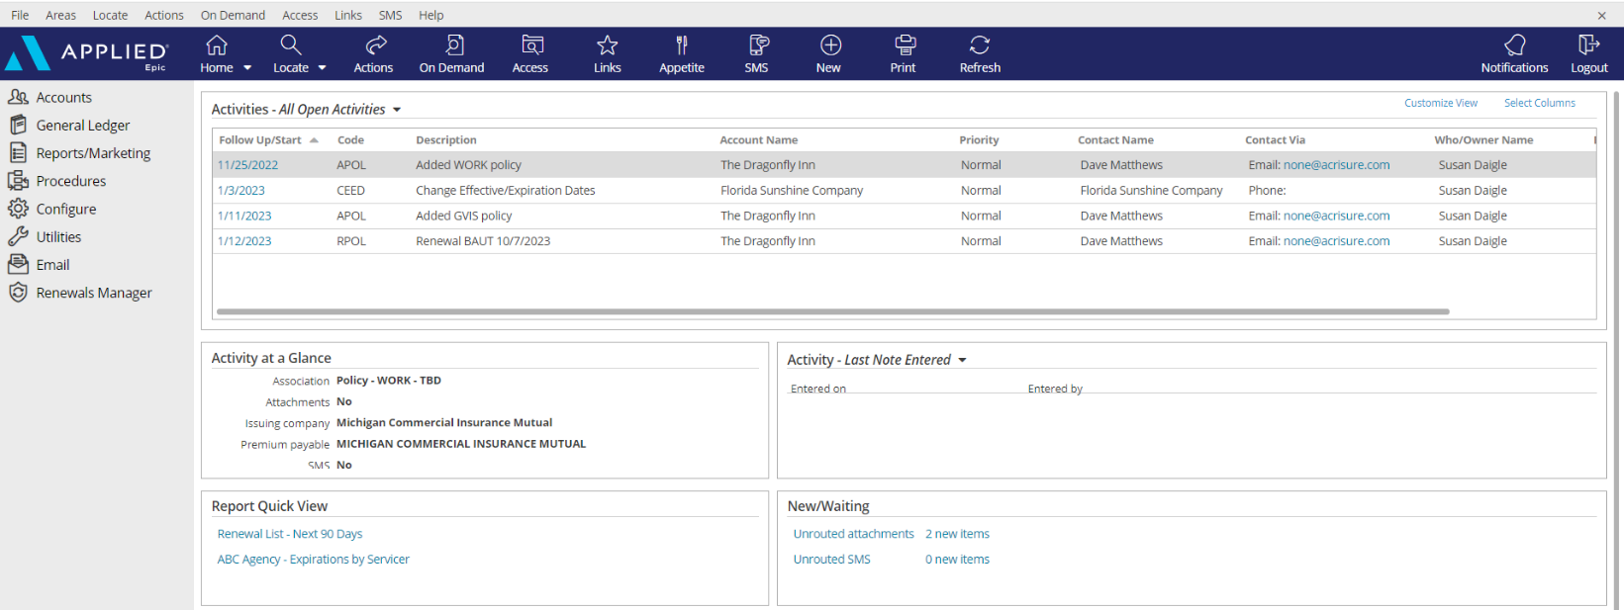

|  |
| --- |
| 1. **Open Activities** (suspense, follow up, to-do list)    * Use **“Select Columns”** to add columns to your view.    * The position of the columns can also be changed by clicking and dragging the column headers to the desired location.    * Sort columns in ascending or descending order by clicking on the column header 2. **Activity at a Glance** – displays information about the highlighted activity 3. **Activity Tasks** OR **Last Note Entered** – if a task within an activity is assigned to you, the task will appear here only if the activity above, associated with the task, is highlighted. The view can be changed from “Activity – Tasks” to “Last Note Entered” by clicking the dropdown arrow and selecting the appropriate option. 4. **Report Quick View** – Created reports can be sent to Report Quick View for easy access. Just click the link and the report will open. Data displayed is in real time and will be refreshed as of the date it is opened 5. **New/Waiting** – If your agency has opted to use Front End Scanning, scanned mail can be accessed by clicking the “Unrouted Attachments” link. The number of items in your “inbox” will also display. 6. **Navigation Panel** – Items listed here will direct you to distinct parts of Epic or the client’s account while on the locate screen or within the client account. Items listed change depending on which screen is being utilized. This is known as the “View” panel. 7. **Blue Options Bar** – Each icon contains action options, which change depending on which screen is being opened. Think of this as the “Do” bar. 8. **Log Out button** – Clicking this button will close all the open screens/windows and log out of Epic. 9. **Locate** – Click the dropdown arrow to see list of last 20 accounts accessed |

## Client Accounts

### Account Sources – REQUIRED FIELD

|  |  |  |  |  |  |  |  |  |  |  |  |  |  |  |  |  |  |  |  |  |  |  |  |  |  |  |  |  |  |  |  |  |
| --- | --- | --- | --- | --- | --- | --- | --- | --- | --- | --- | --- | --- | --- | --- | --- | --- | --- | --- | --- | --- | --- | --- | --- | --- | --- | --- | --- | --- | --- | --- | --- | --- |
| |  | | --- | | 0. Cross Sell-Platform | | 1. AM/AE Solicited | | 1. Producer Solicited | | 2. Referral - Acrisure Cyber Services | | 2. Referral - Acrisure Title Partner | | 2. Referral - Association | | 2. Referral - Broker - Acrisure | | 2. Referral - Broker Non-Acrisure | | 2. Referral - Carrier | | 2. Referral - Client | | 2. Referral - Employee | | 2. Referral – FBC Mortgage | | 2. Referral - Financial Partner/WM | | 2. Referral - GA | | 2. Referral - LGIT | | 2. Referral – Loan Officer | | 2. Referral – Mariner Wealth | | 2. Referral - Other | | 2. Referral – Payroll Firm | | 2. Referral - Realtor | | 2. Referral - TPA | | 3. Marketing - Acrisure.com | | 3. Marketing – Internet Search | | 3. Marketing - Other | | 3. Marketing – Social Media | | 3. Marketing - Telemarketing | | 3. Marketing - Tradeshow | | 4. Other/Unknown | | 5. Win Back | | 6. Call In/Walk In | | Z. Update Needed | | **Account Source is a Required Field.**  **Be sure to select the appropriate one for tracking and reporting purposes.**  If the policy source is unknown,  select “**Update Needed**” to update at a later time. |

### Servicing Roles

|  |  |  |  |  |  |  |  |
| --- | --- | --- | --- | --- | --- | --- | --- |
| **External Service Team** | |  | | --- | | Acrisure Service Center | | Carrier Service Center | | GA - Emerson Reid | | GA - Martin Insurance Services * | | GA - PGM * | | GA - Suvaun * |   **When an account and/or policy is managed by an external service team (the Acrisure Service Center, a Carrier Service Center, or a General Agent on the EB side), select the appropriate Service Team from the drop-down list.**  **Note:**  **An Acrisure-owned GA will be indicated with an asterisk.** |
| Marketing |
| P&C Client Advisor 1 |
| P&C Client Advisor 2 |
| P&C Servicer 1 |
| P&C Servicer 2 |
| P&C Claims |
| P&C Account Executive |
| Surety Client Advisor |
| Surety Servicer |
| EB Client Advisor 1 |
| EB Client Advisor 2 |
| EB Servicer 1 |
| EB Servicer 2 |
| EB Claims |
| Non-Insurance Product Sales |
| CRM Relationship Manager |
| Risk Consultant |
| EB Underwriter |

### Locate Account

|  |
| --- |
| * Click the **Locate** button to **search** for existing clients   **Locate Options:**   * + **Account/Business Name** – *contains full or partial account name*   + **Claims: Additional Party** – by involvement type, name, or phone number   + **Insurer Claim#** - must be exact & complete   + **Internal Claim#** - must be exact & complete   + **Date of Loss** – *range*   + **Last name, first name** – *begins with* and will search account detail name field and individual contacts   + **Lookup Code** – *begins with*   + **Phone Number** – must be exact & complete   + **Policy #** - *contains*   + **Prior Account ID** – *begins with* (from your prior system)   + **Relationship** – relationship type and then account name   + **Submission ID** – *begins with* (in marketing)   + **Vehicle Registration Number** * Click the **Locate** button to **add new** client accounts. * Click the **drop-down arrow** on the Locate button to access the last 20 accounts accessed (including client accounts, employee accounts, company accounts, etc.) |

### Close Out of an Account Record

|  |
| --- |
| Locating and selecting an account will create a new tab in the browser. **Close the account record by clicking the X above the Logout button** NOT by clicking the x within the tab at the top. |

## Contacts

|  |
| --- |
| Best Practices   * Add **each** Additional Named insured/Contact into the Contacts tab. |

### Contacts Overview

|  |  |
| --- | --- |
| **Individual Contact** | This is an additional individual contact (person) on the account. By choosing an individual contact, additional fields are made available, such as date of birth, SSN, marital status, driver's license number, etc. Click the lock to the right of the PII fields to secure the field, making it private. |
| **Primary Contact** | This is an **individual contact** that should be selected as the primary contact for the account. To make a contact **Primary,** click **ACTIONS** **> Change Primary Contact**. The Primary Contact is displayed in the Rolodex Card on the bottom left corner of the client’s account. |
| **Category** | Contacts are categorized based on their relationship to the Account: Contact Only—Policy Only—Both Contact & Policy |
| **Description** | Add **Description** to best represent the position or role of the contact (i.e., owner, manager, etc.) Select the appropriate description(s) for each Contact. This information is used for tracking and reporting. **This is a required field** |
| **Classifications** | **Be sure to select** the appropriate contact classification.  DM=Decision Maker; PC=Primary Contact   |  |  | | --- | --- | | __User - Benefits Technology | _EB Compliance | | __User - CSR24/Portal | _EB Compliance Newsletter | | __User - HR Portal | _EB Eligibility Contact | | __User - Indio | _EB HRLS Compliance Summit | | __User - Insite Portal | _EB Plan Admin | | __User - Succeed | _HR Leader | | __User - Zywave | _Personal (DM) | | __User - Zywave LMS | _Personal (PC) | | _Certificates | _Risk Management (PC) | | _Commercial (DM) | _Safety (PC) | | _Commercial (PC) | _Surety (DM) | | _Cyber (DM) | _Surety (PC) | | _Cyber (PC) | _Work Comp (DM) | | _EB (DM) | _Work Comp (PC) | | _EB (PC) | 401K Plan Administrator | |  | Acrisure Webinars | |

### Add Additional Contacts

#### Add Individual Contact

|  |
| --- |
| 1. From the client’s account, click **Contacts** in the left panel 2. Click the **ADD** button 3. Select the **Individual** radio button 4. Enter First Name, Last Name 5. **Category:** Indicate whether contact only, policy only, or both contact & policy 6. **Description:** Select the appropriate description for this contact 7. Enter the address. If the account address is the same as the contact address, check the box for Use Account Address   Enter phone number (indicate if mobile) and email address ***NOTE: Email is a required field***. If the contact does not have an email address, enter [none@acrisure.com](mailto:none@none.com)     1. Click **DETAIL** to add preferences and business information such as FEIN, Business type, etc.   Click **Save Contact**. |

#### Add Business Contact

|  |
| --- |
| 1. From the client’s account, click **Contacts** in the left panel 2. Click the **ADD** button 3. Select the **Business** radio button 4. Enter Business name 5. **Category:** Indicate whether contact only, policy only, or both contact & policy 6. **Description:** Select the appropriate description for this contact 7. Enter the address. If the account address is the same as the contact address, check the box for Use Account Address 8. Enter phone number (indicate if mobile) and email address.   ***NOTE:*** If the contact does not have an email address, enter [none@acrisure.com](mailto:none@none.com)   1. Click **Detail** 2. **Edit** Contact 3. Enter required \***NAICS**; click **Save Contact Summary** 4. Update Preferences and Business tabs: = Business details, Identification numbers = FEIN, SSN, etc and Company revenue, payroll, payroll cycle, etc. |

## Best Practice Guide for Addresses

|  |
| --- |
| ***Contact information is an important part of the Client Account record. Please follow these guidelines to keep the data clean.*** |

### Client Name

|  |
| --- |
| * Enter only **ONE** business name in the Account Name box, **not multiple** * Enter **legal** business name * Additional Business names, DBAs, or Subsidiary Names should be added to the **Contacts** area of the client account. |

### Client Addresses

|  |
| --- |
| * **First Address Line**: Enter Street address only – No Names, DBA’s, or PO Boxes * DO NOT add P.O. Box instead, add the entity as another business contact with L-Mailing as the description   A screenshot of contact information  Description automatically generated   * + It is okay to include Suite Number, Apartment Number, and Floor Number with the street address.   **A screen shot of a computer  Description automatically generatedA screen shot of a computer  Description automatically generatedDO NOT INCLUDE DBA NAME OR NAME OF INSURED CONTACT IN THE FIRST LINE OF THE ADDRESS FIELD. See proper instructions on adding a** **DBA** **and a** **Contact****.**   * **Be sure to enter City, State & Zip Code** * **Address validation tools** are used in Epic Browser and AcriVision mapping and will create errors if the street address is not shown on the first line. * **Add a Contact and Address Description:**   + Contact – Named Insured   + Address – Primary Physical Address * **Additional Mailing or Billing addresses** can be set up as Contacts – do not forget to add address and Contact descriptions such as DBA, L-Billing, or Post office Box. |

## Sticky Notes

|  |
| --- |
| 1. Add a sticky note by clicking the **NEW** button in the blue Options Bar within the Client Account      1. Enter note 2. Collapse the note by clicking the double up arrows 3. Manage the Sticky Note by clicking the three vertical dots      1. Delete the Sticky Note by clicking the X 2. Add a New Sticky Note by clicking the + |

## Email

### Microsoft Outlook Integration with Epic

#### Set Outlook Email Integration Default

|  |
| --- |
| ***Setting Outlook as the Email Integration Option will allow the launch of Outlook from Epic. Emails sent from Epic will automatically attach to the client’s account and will also add a Sent Item in Outlook.***  ***This integration applies to emailing from Attachments or from any of the blue email links within a client’s account. This does NOT apply to the Distribution Manager.***   1. From the Home Base, click **Configure** from the left Navigation Panel 2. Click **User Options** and select **Email** 3. Select the Outlook radio button      1. Click **Finish.** |

### Configuring Attach to Epic Plug-In in Outlook

|  |
| --- |
| 1. Open Microsoft Outlook 2. Find **Attach to Epic** in the ribbon and click the down arrow next to the word **Applied**      1. Select Browser 2. Enter the Applied Epic Browser URL 3. Choose a Default Browser      1. X out of this window |

### Email from Distribution Manager

#### Set up Distribution Manager Email Account

|  |
| --- |
| 1. From the **Home Base**, click **Configure** from the left Navigation Panel 2. Click **User Options** and select **Distribution Email Accounts** 3. If more than one account is listed, **delete all except Primary Email Account** 4. Highlight Email Account and click the **Edit** pencil 5. Enter the Distribution Email Details as follows    * Associated Agency = select your Agency from the dropdown list    * Display Name = enter your full name    * Reply address = enter your email address 6. Click **Finish**   ***NOTE: For those whose legal entity name is being retained (for example: due to earnout or cluster agreement.) it is important NOT to use the Acrisure email address; use your legal entity’s email address.*** |

#### Set up Distribution Email Signature

|  |
| --- |
| 1. From **Outlook**, Copy your email signature (Right Click/Copy or CTRL+C) 2. Go back to EPIC 3. From the **Home Base**, click **Configure** from the left Navigation Panel 4. Click **User Options** and select **Distribution Email Accounts** 5. With your DMS email account highlighted, click the edit pencil 6. Click the **Email Signature** tab 7. Click the **Add** button (+) 8. Enter a **Description** for your signature and check the **Default** box      1. In the white space below the format buttons, paste the email signature which was copied in Step 3 above (Right Click/Paste or CTRL+V) |

#### *If Acrisure Logo does not paste appropriately follow the steps below*

|  |
| --- |
| 1. Right click your Acrisure logo from your email signature inside of outlook and click Save as picture.      1. Go back into Epic, Click to Highlight box where logo should appear. 2. Select Insert/Edit Image Button 3. Search for Logo saved to your computer      1. Once Logo is selected click Open, then Click blue Ok button. 2. Resize Acrisure logo as needed. 3. Click **Finish** 4. The email signature will be listed    Click Finish. |

#### Send Email from Distribution Manager

|  |
| --- |
| As part of the normal workflow, when the ACORD form is ready to print/send, utilize the **Distribution Manager** to send documents.   1. From the **Distribution** Tab, set delivery option to **Email** 2. The **From** field defaults to your email address, however the sender can be changed 3. Add **Signature** (should default) 4. Add more than one recipient, cc, or bcc 5. Enter body of the email with full HTML functionality (change font size/color, add logos, pictures, change alignment, etc. 6. If the documents need to be sent to multiple recipients, use the **Apply To** link to apply the email to all recipients 7. Click **Finish** to send |

## Faxing

### From Distribution Manager

|  |
| --- |
| As part of the normal workflow, when the ACORD form is ready to print/send, utilize **Distribution Manager** to send documents.   1. From the **Distribution** Tab, set delivery option to **Email** 2. Select a “**From**” email address 3. In the “**To**” field, type **fax= [**the fax number (including the 1)] @**efaxds.com** 4. Enter **Subject** line (required) 5. Enter message, if needed      1. Click **Finish** to send. |

## Activities

|  |
| --- |
| Activities in Epic perform three essential functions:   * Add a record to the client file for the action performed * Allow a follow up or Open Activity as a reminder to do something at a current or future date * Permanently document the file with the use of Notes within Activities   ***NOTE: Activities or Notes in an Activity cannot be moved to another account*** |

### Activity Access Levels

|  |  |  |  |  |  |  |  |
| --- | --- | --- | --- | --- | --- | --- | --- |
| |  | | --- | | **Description** | | Accounting | | Financials | | HIPAA | | HR Consulting | | Medicare | |  | |

### Activity Workgroups

|  |  |  |  |  |  |  |  |  |  |  |  |  |  |  |  |  |  |  |  |  |  |  |  |  |  |  |  |  |  |  |  |  |
| --- | --- | --- | --- | --- | --- | --- | --- | --- | --- | --- | --- | --- | --- | --- | --- | --- | --- | --- | --- | --- | --- | --- | --- | --- | --- | --- | --- | --- | --- | --- | --- | --- |
| |  |  | | --- | --- | | **Code** | **Description** | | @APPAY | Applied Pay Default Work Group | | @EXT | External Default Group | | @LEADS | Leads Inbox Default Work Group | | ACCT | Accounting | | APAY | Accounting - Payables | | ARVW | Accounting Review | | CERT | Certificates | | CIDT | ACRISURE Centralized Interface Download Team | | CLM | Claims | | DBSC | Direct Bill Service Center | | INVO | Invoicing | | RSP1 | ReSource Pro | | RCER | ReSource Pro Certificates | |  |  | |  |  | |

### Home Base Open Activities

|  |  |
| --- | --- |
| **Select Columns** | Check or uncheck the columns desired to reflect within the Home Base View   |
| **Customize View** | Allows the addition of other Employee activities to reflect within your own open activities list (if given permission)   |
| **Right Click to Manage** | * **Close Activity** – *follow up action is completed* * **Add Note** – *add notes related to the process which is still pending* * **Add Task** – *assign a portion of the activity process to someone else to work on* * **Change Follow-up Date/Time** – *if the deadline for completing the activity can be moved* * **Change Who/Owner** – *reassign the activity for someone else to take care of, which will move to their Home Base* * **View All Notes** – *Read all notes related to a specific activity process* * **Take Ownership** – *If the activity is assigned to another person or a work group, it can be reassigned to yourself*   ***Note: multi-select activities (CTRL + Click) to apply the above actions to multiple activities at one time*** |

### System Generated Activity Codes

|  |  |  |
| --- | --- | --- |
| **Code** | **Description** | **Event** |
| **@APY** | Applied Pay payment received from &ContactName& | Payment from Client |
| **ACLM** | # Added claim for DOL &DateLoss& | Add Claim |
| **ADD1** | # Add Insured &AcctName& | Add Account |
| **ADD2** | # Add Prospect &AcctName& | Add Account |
| **ADDC** | # Address Applied to Other Items | Address Applied to Other Items |
| **ADSC** | # Add Service | Add Service |
| **AMMK** | # Added master marketing submission for &AcctName& | New Marketing Submission |
| **AOP** | # Add Opportunity | Add Opportunity |
| **APOL** | # Added &PolType& policy effective &PolEffDate& | Add Policy |
| **AUID** | # Issued auto ID card | Issue Auto ID Card |
| **BIND** | # Issued binder &PolDesc& &PolEffDate &Policy#& | Issue Binder |
| **BND1** | # Bind Policy via Master Marketing | Move Marketed Lines to Current Policies |
| **BORP** | # BOR P&C - Agent Received Date: | Add Policy |
| **CEED** | # Change Effective/Expiration Dates | Change Effective/Expiration Dates |
| **CERT** | # Issued Certificate (&OintNm&) | Issue Certificate |
| **CHGA** | # Audit &ServSumEffDate& &ServSumDesc& | Endorse/Revise-Existing Lines |
| **CHGE** | # Change &ServSumEffDate& &ServSumDesc& | Endorse/Revise-Existing Lines |
| **CHGI** | # Internal Correction &ServSumEffDate& &ServSumDesc& | Endorse/Revise-Existing Lines |
| **CHGL** | # &ServSumEffDate& &ServSumDesc& | Endorse/Revise-Add Line Midterm |
| **CPOL** | # Canceled - Lost Policy Eff: &ServSumEffDate& &ServSumDesc& | Cancel Policy/Line |
| **CREW** | # Canceled - Rewritten Policy Eff: &ServSumEffDate& &ServSumDesc& | Cancel Policy/Line |
| **ESIG** | # Send to eSignature | Send to eSignature |
| **EVID** | # Issued Evidence of Insurance &PolDesc& &PolEffDate& | Issue Evidence of Insurance |
| **PROP** | # Proposal Generated | Proposal |
| **REIN** | # Reinstated policy/line | Reinstate Policy/Line |
| **RESC** | # Renew Service | Renew Service |
| **REVI** | # Renewed EOP | Renew Evidence of Insurance |
| **RPOL** | # Renewal &PolType& &PolEffDate& | Renew Policy |

### Manual Activity Codes (F9)

#### For Accounting Workflow Activities – See [SharePoint](https://acrisure.sharepoint.com/:w:/s/ACR-ABSAccountingTeam/ESAdZgcBwPdJt0_n5-hNILkBueeqZpQWrGK6rg54rr9l7g?e=4LVSdM&clickparams=eyJBcHBOYW1lIjoiVGVhbXMtRGVza3RvcCIsIkFwcFZlcnNpb24iOiI0OS8yMzExMzAyODcyNCJ9) for Platform Activity Guide

#### Commercial Lines Workflow Manual Activities

|  |  |  |
| --- | --- | --- |
| **Code** | **Description** | **When to Create Activity** |
| **CARV** | Account Review | Created when an Account Review is initiated |
| **CAU1** | Audit &PolType& effective &PolEffDate& | Created when Audit is received and further information is needed prior to endorsing policy. |
| **CAU2** | Audit - Monthly/Quarterly Reporting Due | Created when Audit for Monthly/Quarterly Reporting is Due. |
| **CBCH** | CL - Benchmarking |  |
| **CBIQ** | CL - Billing Inquiry | Created when a Billing Inquiry is received |
| **CCN1** | CL - Carrier Notice of Cancellation | Created when a carrier notice of cancellation (NOC) is received. |
| **CCN2** | CL - Notice of Cancellation for Non-Payment | Created when a notice of cancellation (NOC) for non-payment is received. |
| **CCOI** | COI Request | Created when a certificate is requested and needs further documentation. |
| **CCRF** | CL - Refer Claim to Claims Team | Created when a Claim is referred to our Internal Claims Team |
| **CCRV** | Claim Review | Created when a Claim Review is needed for the account. |
| **CCTR** | Contract Review | Created when a Contract Review is needed for the account. |
| **CDIV** | Dividend | Created when a Dividend is received. |
| **CDSH** | Client Dashboard | Used only with CLL – Large Commercial Accounts |
| **CEOP** | EOP Request | Created when an Evidence of Property is requested and needs further documentation. |
| **CEXP** | Experience Reporting |  |
| **CLCR** | Loss Control Recommendation | Created when a Loss Control is recommended for the client. |
| **CLRR** | CL - Renewal Review &PolExpDate& &PolType& | Created for tracking and documenting all pre-renewal work |
| **CMVR** | MVR Request | Created when MVR has been requested. |
| **CNCO** | New CL Client Onboarding | Created when we are Onboarding a New Client to our Agency |
| **CQUE** | CL - Coverage Inquiry | Created when a Coverage inquiry is received from the client or an additional interest. |
| **CRCC** | Complex Casualty Pre-Renewal | Auto generated at 210 days before expiration. Can be manually created if additional activities are needed |
| **CRCL** | CL Middle & Large Pre-Renewal | Auto generated at 150 days before expiration. Can be manually created if additional activities are needed |
| **CRCS** | CL Small Pre-Renewal | Auto generated at 150 days before expiration. Can be manually created if additional activities are needed |
| **CREG** | Regulatory Notice |  |
| **CRMK** | Remarket Request | Created and assigned to marketing for renewal marketing |
| **CRSK** | CL - Account At Risk | Created for review of an Account at Risk. |
| **CRUN** | Loss Runs | Created when loss runs are needed or requested. |
| **CSTW** | CL - Stewardship Report | Created when a Stewardship report is needed |
| **CUND** | Underwriting | Created when underwriting has contacted the agency regarding a policy outside of an action activity. |
| **GACR** | Acrisure Real Estate Services Referral | Created by an Account Executive or Account Manager to track when a Real Estate Referral is Received |
| **GACS** | Acrisure Cyber Services Referral | Created by an Account Executive or Account Manager to track when a Cyber Services Referral is Received |
| **GAPT** | Appointment with &AcctName& | Created when an Appointment is made with a Client |
| **GCAL** | Call from &AcctName& | Created when a general call or email is received. |
| **GNRN** | Policy Not Renewed | Created to attach the notice or communication of a client policy not being renewed. |
| **GXFL** | Ex-date follow-up for &AcctName& | Created to reach out to the client in the future to win back their business. |
| **QCYB** | Quote - Cyber | Created for documentation for quoting cyber only. |
| **QNEW** | Quote - New Business | Created for documentation during the new business quoting process. |
| **QREW** | Quote – Renewal/Rewrite | Created for documentation during the rewrite quoting process for midterm or at renewal. |
| **SARV** | Account Review (Surety) | Created for an Account Review is initiated for surety. |
| **SBID** | Bid Bond |  |
| **SFI** | Financial Information - Bonds |  |

## Attachments

### Attachment Naming Conventions

|  |
| --- |
| The Platform naming convention protocol is to start the description with the term (an example: 2024 to 2025 would be 24-25) then the line of business/policy type, followed by a description of the attachment. The table below provides examples for many attachment types. A spreadsheet with more details can be found on the [Mid-Atlantic SharePoint](https://acrisure.sharepoint.com/sites/AcriWorld/Shared%20Documents/Forms/AllItems.aspx?id=%2Fsites%2FAcriWorld%2FShared%20Documents%2FEnterprise%5FSolutions%5FCenter%2FPlatforms%2FMid%5FAtlantic%2FEpic%2C%20CSR24%20%26%20Indio%20Resources&viewid=f6de5ddd%2Dd0d1%2D4fcf%2Daf55%2D3160191957d5) page in the Epic Resources folder.  *If an attachment is received into Epic via eDoc interface, the attachment description should be renamed to match the naming convention and the attachment associated with the applicable open activity, either a Zcode for policy detail download or the user created activity pending receipt of document from carrier (ex: CHGE, APOL, CPOL, RPOL, ZREN).*  The naming convention applies to attachments, not activity description or policy descriptions |

|  |  |  |
| --- | --- | --- |
| **Document** | **Naming Convention** | **Example** |
| Applications, not generated in Epic | YY-YY (Term) Line of Business (ex. General Liability, Homeowner, Notary Bond) Application (type of App) Carrier (if supplemental) signed /not signed | 23-24 D&O Supplemental App Chubb not signed |
| Schedule | YY-YY (Line of Business) Schedule description | 23-24 Commercial Auto Vehicle Schedule; 23-24 Commercial Property BPP Schedule loc 3 |
| Statement of values | YY-YY (Line of Business) Statement of Value | 23-24 Commercial Property Statement of Value |
| Submission to Carrier | YY-YY (Line of Business(es)) submission to (carrier/underwriter/broker description) | 23-24 Commercial Auto, Umbrella, General Liability submission to Mike @ Travelers |
| Quotes | YY-YY (Line of Business) Quote (Carrier) $Premium | 23-24 Homeowner Quote Safeco $2000 |
| Bind Order from Client email | YY-YY (Line of Business) (Carrier/Broker) bind order from client eff date | 23-24 Homeowner Safeco Bind order from insured eff 09/15/23 |
| Bind Order to Carrier/Broker | YY-YY (Line of Business) bind order to (carrier/broker) eff date | 23-24 Comm Auto Bind order to Hanover eff 10/01/23 |
| Bind Confirmation from Carrier/Broker | YY-YY (Line of Business) bind confirmation from (carrier/broker) | 23-24 Commercial Auto Bind confirmation from Hanover |
| Binder from Carrier | YY-YY (Line of Business) Binder (Carrier/Broker) eff date | 23-24 Personal Auto Liberty Mutual Binder eff 11/15/23 |
| Policy | YY-YY (Line of Business) Policy (carrier) eff date Premium | 23-24 Comm Package Policy Travelers eff 2/1/2024 $2500 |
| Audit | YY-YY (Line of Business) Audit (carrier) eff date Premium Change | 23-24 Work Comp Audit Travelers eff 11/04/23 $250RP |
| Email request for Certificate or Evidence | YY-YY Certificate Request for (holder name/project name, etc.) | 23-24 Cert request for City of Newark Project #1234 |
| Change Request email from insured | YY-YY (Line of Business(es)) From insured, (describe change request) eff date | 23-24 Personal Auto request from insured incr Coll ded to $500 eff 2-14-2024 |
| Change Request to Carrier/Broker | YY-YY (Line of Business) change request to (Carrier) describe change, eff date | 23-24 Personal Auto change request to Travelers, add 2023 Ford Escape VIN #12345 eff 12/15/23 |
|  |  |  |
| **Document** | **Naming Convention** | **Example** |
| Endorsement | YY-YY (Line of Business) Endt # | 24-25 Commercial Auto Endt #3 add 2024 Dodge Ram #98653 eff 2/15/2024 $500AP |
| Cancellation Request from Client | YY-YY (Line of Business) cancellation request from insured eff date | 23-24 Personal Auto cancellation request from insured eff 11.16.2023 |
| Cancellation Request to Carrier/Broker | YY-YY (Line of Business) cancellation request to (carrier) (eff date of canc) | 23-24 Personal Auto signed LPR to Safeco eff 11/16/2023 |
| Cancellation Endorsement (other than for Non-Pay) | YY-YY (Line of Business) Cancellation eff date, reason | 23-24 CAU1 Cancellation eff 9/23/2023 Insured request Sold Property |
| Notice of Intent to Cancel for Non-Payment and/or Cancel for Non-Pay Endorsement | YY-YY (Line of Business) Intent to Cancel for NonPay eff date $amount due | 23-24 Work Comp Intent to Cancel NonPay eff 1/25/24 $500 due |
| Notice of Non-Renewal | YY-YY (Line of Business) Notice of Non-renewal, reason | 23-24 Commercial Property Notice of Non-renewal, Claims |
| Reinstatement | YY-YY (Line of Business) Reinstatement eff date | 23-24 Personal Auto Reinstatement eff 2/14/2024 |
| Carrier/Broker Invoice for Agency Bill | YY-YY (Line of Business) Carrier/Broker Invoice eff date | 23-24 Cyber Broker Invoice eff 10/01/2023 |
| Claim details from insured via email | DOL (date of loss) Claim details | DOL 12/15/23 General Liab Travelers Customer trip and fall details from manager |
| Claim Emails | DOL (date of loss) (enter description of email) | DOL 12/25/23 email to insd - adjuster will provide details |
| Police Report | DOL (date of loss) Police Report | DOL 11/15/23 Police report |
| Adjuster notes/Status updates | DOL (date of Loss) Adjuster notes or Status Update | DOL 11/15/23 Adjuster Notes; DOL 12/15/23 Claim Status |
| Claim Notices from Carrier | DOL (date of loss) Claim Notice Carrier Claim number if known | DOL 11/15/23 Claim Notice # 123456 |
| Claim Photos | DOL (Date of Loss) Photos | DOL 11/15/23 Photos |
| Suit Papers | DOL (date of loss) Suit Papers | DOL 9/15/23 Suit Papers |
| Appraisal - building/real estate | YY-YY (Line of Business) Appraisal loc description | 24-25 Homeowner Appraisal Loc 1 123 Main St |
| Appraisal - Jewelry/Fine Arts/Antique Auto (used for agreed value) | YY-YY (Line of Business) Appraisal description of item | 23-24 Homeowner Appraisal Diamond Engagement Ring |
| Inspections | YY-YY (Line of Business) inspection | 23-24 Comm Property Inspection report from Carrier |
| Loss Control Report/Risk Management Documents | YY-YY (Line of Business) (loss control report/risk control document) describe | 23-24 Work Comp Loss Control Report site visit 10/20/2023 |
| Emails to/from UW/Client/Team | YY-YY (Line of Business) description of email | 24-25 General Liability email to UW reg exposure exclusion |

### Attach using Add Attachment Button located in Attachment area:

|  |
| --- |
| 1. Click the **ADD** Button (+)    1. Select **Existing File** (from outside of Epic (i.e., local or network drive))    2. Select **Document** to access the Form Letter library    3. Select **eForm** to add a form filler ACORD form from the eForms library   ***Note:*** *when creating initial activity, it is best practice to associate activity to the policy level. If there is no policy when activity is created, associate activity to Account level.* |

### Adding Attachments and Documents by Dragging & Dropping into Epic

|  |
| --- |
| 1. Drag & Drop from Outlook, Network folder, or Desktop into Epic 2. Attach all Documentation to the corresponding *ACTIVITY*   ***NOTE: When creating initial activity, it is Best Practice to attach Activity to the Policy level. If there is no Policy when Activity is created, attach Activity to the Account level.***    Check the Client Accessible box to make an attachment available in the client portal (CSR24)  Remove description and update using Platform Naming Convention  Use this feature to quickly find important documents such as policy dec pages, audits, endorsements, or other important documents.  Select the appropriate access level for security |

**Add Attachments and Documents using Attach to Epic Plug–In**

|  |
| --- |
| **Attaching New Email Using Attach to Epic Plug-In**   1. Click **NEW Email** Button in Outlook 2. Checkbox **Attach to Epic** Box 3. Add Client Email Address in the To Field, Type Title in Subject Line and Type out body of email. When finished with email and all relevant documents are attached, click **SEND**. 4. Attach To Tab will open in Browser 5. Click Magnifying Glass to the right of the Code Field to Locate Client. Click **Finish** Once Account is found. 6. Under Attach To – Identify and select the appropriate dropdown (Policy or Activity) for where the Email and/or documents should be attached to. 7. Once all required fields are completed, Click **Finish** and email will be routed into Applied.   **Attaching Existing Email Using Attach to Epic Plug-In**   1. Right Click on existing email in Outlook and select Attach to Epic 2. Attach to Tab will open in Browser 3. Click Magnifying Glass to the right of the Code Field to Locate Client. Click **Finish** Once Account is found. 4. Under Attach To – Identify and select the appropriate dropdown (Policy or Activity) for where the Email and/or documents should be attached to. 5. Once all required fields are completed, Click **Finish** and email will be routed into Applied. |

### Managing Unrouted Attachments

|  |
| --- |
| Documents that arrive via USPS and are scanned in at a central location, will be placed in the servicers Unrouted Attachments. Unrouted Attachments are located in the New/Waiting area on the Home Base and functions as an electronic Inbox. Servicers should review their Unrouted Attachments every day by clicking on the link.  A screenshot of a computer  Description automatically generated  Unrouted attachments are listed in the Inbox area to the left of the screen and there is a Preview pane on the right. To preview each document, select an item. Double click the selected document to open in a read only mode.  A screenshot of a computer  Description automatically generated  Documents in Unrouted Attachments are to be assigned to the appropriate account/activity/policy line using the following steps:  Highlight/Select the attachment you want to manage, Click **Actions** (or right click on attachment)  Select from the Dropdown  **A screenshot of a computer  Description automatically generated**   1. **Attach Image –**  * A screenshot of a computer    Description automatically generatedAttach to Client; Select Lookup Code * Account Lookup by Account Name Contains * Attach to Account, Activity, Policy, Claim * A screenshot of a computer    Description automatically generatedUpdate Description of Attachment to the platform Naming Convention  1. A screenshot of a computer     Description automatically generated**Edit Details –** Edit the description of the scanned item 2. **Reassign** to Other Employee  * Search where **Account Name Contains** enter first or last name * Click Find * Select Employee * Click Finish   A screenshot of a computer  Description automatically generated   1. **Recycle** to delete unrouted attachment 2. **Save to Downloads Folder** to save unrouted attachment to your Downloads folder file on your computer  * This allows you to drag and drop from Downloads folder file into activity if needed. |

### Attachment Access Levels

|  |  |  |  |  |  |  |  |  |  |  |  |  |  |  |
| --- | --- | --- | --- | --- | --- | --- | --- | --- | --- | --- | --- | --- | --- | --- |
| Access levels allow restriction of access to attachments by granting security rights to certain groups. The default Access Level = Public.   |  |  | | --- | --- | | **Access Level** | **Description** | | 1 | HIPAA | | 2 | Accounting | | 3 | Financial Services | | 4 | Client Financials | | 5 | HR Consulting | | 6 | Medicare | |

### Attachment Actions

|  |  |
| --- | --- |
| Click **ACTIONS** | * **Convert to PDF** – *Converts any document to PDF format in two clicks; can also combine multiple documents into one PDF document* * **Distribute Attachments** – *Uses Distribution Manager to email documents to client contacts* * **Edit Attachment Detail** – *Edit description, association, access levels, and folder* * **Move Attachment** – *Move attachment to another account, folder, etc.* * Policy Checking (Do Not Use) * **Reactivate Attachment** – *Used to remove an attachment from the Inactive area* * **Send via CSIO eDelivery –** NOT APPLICABLE * **Send to eSignature** – *Launches DocuSign* * **Send Via Email** – *Emails attachment through Outlook* |

***PLEASE FOLLOW THE ATTACHMENT NAMING CONVENTION PROTOCOL***

**.**

### Finding and Viewing Attachments/Documents

|  |
| --- |
| * **Important Policy Documents:** In the attachments list view, click the link “Show Only Important Policy Documents” to view all documents being previously marked as “Important”   To revert to all documents, click “Show All Documents.” This link serves as a filtering tool.     * **Filters:** Choose a filter: Ex. Attached within last 6 months.     Filtering by multiple Types of Business is also an option and can be set as the filter default |

### Folder Structure

|  |  |  |  |  |  |  |  |  |  |  |  |  |  |  |  |  |  |  |  |  |  |  |  |  |  |  |  |  |  |  |  |  |  |  |  |  |  |  |  |  |  |  |  |  |  |  |  |  |  |  |  |  |  |  |  |  |  |  |  |  |  |  |  |  |  |  |  |  |  |  |  |  |  |  |  |  |  |  |  |  |  |  |  |  |  |  |  |  |  |  |  |  |  |  |  |  |  |  |  |  |  |  |  |  |  |  |  |  |  |  |  |  |  |  |  |  |  |  |  |  |  |  |  |  |  |  |  |  |  |  |  |  |  |  |  |  |  |  |
| --- | --- | --- | --- | --- | --- | --- | --- | --- | --- | --- | --- | --- | --- | --- | --- | --- | --- | --- | --- | --- | --- | --- | --- | --- | --- | --- | --- | --- | --- | --- | --- | --- | --- | --- | --- | --- | --- | --- | --- | --- | --- | --- | --- | --- | --- | --- | --- | --- | --- | --- | --- | --- | --- | --- | --- | --- | --- | --- | --- | --- | --- | --- | --- | --- | --- | --- | --- | --- | --- | --- | --- | --- | --- | --- | --- | --- | --- | --- | --- | --- | --- | --- | --- | --- | --- | --- | --- | --- | --- | --- | --- | --- | --- | --- | --- | --- | --- | --- | --- | --- | --- | --- | --- | --- | --- | --- | --- | --- | --- | --- | --- | --- | --- | --- | --- | --- | --- | --- | --- | --- | --- | --- | --- | --- | --- | --- | --- | --- | --- | --- | --- | --- | --- | --- | --- | --- | --- | --- |
| |  |  |  |  | | --- | --- | --- | --- | | Folder | Subfolder Folder 1 | Subfolder 2 | Notes | | Actuarial |  |  |  | | Bonds | Agreements & Contracts |  |  | | Executed Bonds | Performance & Payment |  | | Position |  | | All Others |  | | Bid Bonds |  |  | | Claims |  |  | | Correspondence |  |  | | Financial Statements |  |  | | Reports/Summaries |  |  | | Underwriting |  |  | | Broker of Record |  |  |  | | Compensation Consulting |  |  |  | | Contracts & Agreements |  |  | Agency Fee and Service Contracts | | eDocs |  |  |  | | Prior Database Attachments |  |  | All migrated documents from legacy systems | | Property & Casualty | Applications |  |  | | Appraisals |  |  | | Audits |  |  | | Auto IDs |  |  | | Binders – Epic Generated |  |  | | Cancellations/Reinstatement/  Non-Renewal |  |  | | Certificates |  |  | | Change Requests |  | The actual endorsement pdf attach at the policies folder | | Claims | Claim Correspondence |  | | Claim Invoices |  | | Claim Payments |  | | Estimates |  | | Litigation |  | | Loss Notice |  | | Loss Runs |  | | Photos |  | | Correspondence |  | General corro that doesn’t fit in another folder | | Evidence of Insurance |  |  | | Loss Runs |  |  | | Marketing New and Renewal | Submissions/Quotes |  | |  | Binding |  | | MVR’s |  |  | | Policies/Endorsement | All Other Policies | These should be the pdf of policy dec pages and endorsements | | Auto | | Liability | | Package/BOP | | Property | | Umbrella/Excess Liability | | Workers Compensation | | Policy Checking |  |  | | Proposal/Summary |  |  | | Reports | Loss Control/Inspection |  | | Schedules |  |  | |

### Folder View

|  |
| --- |
| * Use folders to organize client documents (Optional) * Folder structure is pre-determined by Acrisure * To see documents in folders, click Attachments view and select Folder View from the drop-down list * Select the folder (i.e., Correspondence, Invoices, Policies, etc.) * Click the expander in the left panel to see sub folders |

### Form Letter Templates

|  |
| --- |
| To select a form letter:   1. Click the Attachments area in the Client account 2. Click the **ADD** button (+) 3. Select Document – click Continue      1. Select a **Template Folder** (i.e., Commercial) 2. Select the form letter from the dropdown list      1. Under the Contact tab, check the recipient of the letter 2. Click the Policy/Claim tab and select a policy or claim to reference in the letter      1. Click **Continue** 2. Change attachment description if needed 3. Click **Finish** 4. Epic data will merge with Microsoft Word and letter will open 5. Update letter as needed. When finished, click the X at the top right to close the Word document 6. Click **YES** to save document as an attachment 7. The Attachment will be saved in WORD format; however, if sending the letter via email or to eSignature, be sure to Convert to PDF first, as follows:    1. Right Click on the WORD attachment    2. Select “Convert to PDF”    3. Click **Finish** 8. From the attachments area, find the PDF version of the form letter, right click and either “Send to eSignature” for DocuSign, or “Send Via Email” to send from Outlook. 9. If “Send Via Email” an attachment screen will pop up. The description can be changed for the email attachment if needed. |

### Access Filter

|  |
| --- |
| The Access button will filter items for a specific policy, activity, transaction, within the **Client’s Account**  **Example:**   1. From the policy screen, select a **policy** 2. Click the **Access** button 3. Select an option:    * **Activities** = displays all the activities associated with the selected policy    * **Attachments** = displays all the attachments associated with the selected policy    * **Claims** = displays all the claims associated with the selected policy    * **Opportunities** = displays all the sales opportunities associated with the selected policy    * **Services** = displays all the services associated with the selected policy    * **Proofs** = displays all the Proofs associated with the selected policy    * **Transactions** = displays all the transactions associated with the selected policy    * **Auditing** = displays all the documents a client has access to via the CSR24 Portal    * **Notifications** = displays notifications related to the selected policy   ***Note: Use the Access button to filter attachments, Example: Highlight policy, Access/Attachments, and only the attachments associated with the policy will appear.*** |

## Policy Basics

### Policy Sources – REQUIRED FIELD

|  |  |
| --- | --- |
| 0. Cross Sell-Platform**​** | **Account Source is a Required Field.  Be sure to select the appropriate  Source for tracking and reporting purposes.**  If the policy source is unknown, select “**Update Needed**” to update at a later time. |
| 1. AM/AE Solicited **​** |
| 1. Producer Solicited**​** |
| 2. Referral - Acrisure Cyber Services**​** |
| 2. Referral - Acrisure Title Partner**​** |
| 2. Referral - Association**​** |
| 2. Referral - Broker - Acrisure **​** |
| 2. Referral - Broker - Non-Acrisure **​** |
| 2. Referral - Carrier |
| 2. Referral - Client**​** |
| 2. Referral - Employee**​** |
| 2. Referral – FBC Mortgage |
| 2. Referral - Financial Partner/WM**​** |
| 2. Referral - GA**​** |
| 2. Referral – Loan Officer |
| 2. Referral – Mariner Wealth |
| 2. Referral - Other**​** |
| 2. Referral – Payroll Firm**​** |
| 2. Referral - Realtor |
| 2. Referral – TPA**​** |
| 3. Marketing - Acrisure.com**​** |
| 3. Marketing – Internet Search |
| 3. Marketing - Other**​** |
| 3. Marketing – Social Media |
| 3. Marketing - Telemarketing**​** |
| 5. Win Back**​** |
| 6. Call In/Walk In**​** |
| Z. Update Needed**​** |

### Commercial Policy Types

|  |  |  |
| --- | --- | --- |
| **Code** | **Description** | **Application Detail** |
| **ALIA** | Agriculture Liability | Agri-Business Liability |
| **APK1** | Agriculture Package-AG | < None > |
| **APK2** | Agriculture Package-CL | < None > |
| **APP** | Agriculture Personal Property | Agri-Business Schedule and Unscheduled Personal Property |
| **APRO** | Agriculture Property | Agri-Business Property Section |
| **CAV0** | Aircraft | < None > |
| **CAV1** | Aviation Drones/UAV | < None > |
| **CAV2** | Aviation General Liability | < None > |
| **BCM1** | BOND Commercial (NR) | Surety Report Detail |
| **BCM2** | BOND Commercial (Recurring) | Surety Report Detail |
| **BCON** | BOND Contract (NR) | Surety Report Detail |
| **BCWA** | BOND Contract Warranty (NR) | Surety Report Detail |
| **BFI2** | BOND Fidelity / ERISA - CL | < None > |
| **BLIC** | BOND License & Permit | Surety Report Detail |
| **BMAI** | BOND Maintenance (NR) | Surety Report Detail |
| **BNOT** | BOND Notary | Surety Report Detail |
| **BPER** | BOND Performance & Payment (NR) | Surety Report Detail |
| **BPOF** | BOND Public Official | Surety Report Detail |
| **BSUB** | BOND Subdivision | Surety Report Detail |
| **BTRE** | BOND Treasury | Surety Report Detail |
| **CADD** | Commercial AD&D | < None > |
| **C-AF** | Captive Assessment Fee | < None > |
| **CANI** | Animal Mortality | < None > |
| **CAU1** | Business Auto | Business Auto Detail |
| **CAU2** | Business Auto - Excess | Business Auto Detail |
| **CAU3** | Commercial Recreational Vehicle | Business Auto Detail |
| **CAU4** | Business Auto - Physical Damage | Business Auto Detail |
| **CBAI** | Bailee | Property Detail |
| **CBM** | Boiler & Machinery | Boiler & Machinery Detail |
| **CTRB** | Bobtail | Truckers/Motor Carriers Detail |
| **CBOP** | Business Owners Policy | Business Owners Detail |
| **CBR** | Builders Risk - Project Specific (NR) | Installation/Builders Risk Detail |
| **CBR2** | Builders Risk - Reporting Form | Installation/Builders Risk Detail |
| **ZCL1** | Cyber Liability | CF Cyber Privacy & Data Breach Insurance Info |
| **ZCL3** | Cyber Liability - Excess | < None > |
| **CCOW** | Control of Well | < None > |
| **CCRM** | Crime | Crime Detail |
| **CCRP** | Crop & Hail | < None > |
| **CDIC** | Difference In Conditions | Property Detail |
| **ZDO1** | Directors & Officers | CF Directors & Officers |
| **ZDO2** | Directors & Officers - Excess | CF Directors & Officers |
| **CE01** | E&O | CF Errors & Omissions |
| **CE02** | E&O - Accountants | CF Errors & Omissions |
| **CE03** | E&O - Architects & Engineers | CF Errors & Omissions |
| **CE04** | E&O - Bankers | CF Errors & Omissions |
| **CE05** | E&O - Contractors | CF Errors & Omissions |
| **CE06** | E&O - Lawyers | CF Errors & Omissions |
| **CE07** | E&O - Med Mal | CF Errors & Omissions |
| **CE08** | E&O - Miscellaneous | CF Errors & Omissions |
| **CE09** | E&O - Public Officials | CF Errors & Omissions |
| **CE10** | E&O - Pension Trustee | CF Errors & Omissions |
| **CE11** | E&O - Excess | CF Errors & Omissions |
| **CE16** | E&O - Property Managers | CF Errors & Omissions |
| **CEBL** | Employee Benefits Liability | < None > |
| **CEDP** | Electronic Data Processing | Electronic Data Processing Detail |
| **CEF1** | Equipment Floater | Equipment Floater Detail |
| **CEF2** | Commercial Fine Arts | Equipment Floater Detail |
| **CEF3** | Jewelers Block | Equipment Floater Detail |
| **CEML** | Employed Lawyers | < None > |
| **ZEP1** | Employment Practices Liability | CF Employment Practices Liability |
| **ZEP3** | Employment Practices Liability - Excess | < None > |
| **CEQ** | Commercial Earthquake | Property Detail |
| **CEQU** | Equine | CF Animal Mortality |
| **CERP** | Extended Reporting Period | General Liability Detail - Simplified |
| **CFGL** | Foreign General Liability | General Liability Detail - Simplified |
| **ZCFL** | Fiduciary Liability | CF Fiduciary Liability |
| **ZCFE** | Fiduciary Liability - Excess | CF Fiduciary Liability |
| **CFL1** | Commercial Flood (NFIP) | Flood Insurance Preferred Risk Policy Application |
| **CFL2** | Commercial Flood (Private) | Flood Insurance Preferred Risk Policy Application |
| **CFL3** | Commercial Flood - Excess | Flood Insurance Preferred Risk Policy Application |
| **CGD** | Garage & Dealers | Garage and Dealers Detail |
| **CGL1** | General Liability | General Liability Detail - Simplified |
| **CGL2** | General Liability - Excess | Umbrella Detail |
| **CGL3** | General Liability - Project Specific (NR) | General Liability Detail - Simplified |
| **CGL4** | General Liability - OCIP / Wrap (NR) | General Liability Detail - Simplified |
| **CGS** | Glass & Sign | Glass and Sign Detail |
| **CGSD** | Group State Mandated Disability (CL) | CF Group State Mandated Disability |
| **CHUL** | Hull & Machinery | < None > |
| **CID** | Commercial Identify Theft | < None > |
| **CKR** | Kidnap & Ransom | CF Kidnap & Ransom |
| **CLD** | Legal Defense | < None > |
| **CLL** | Liquor Liability | CF Liquor Liability 2 |
| **CMOL** | Marina Operators Liability | < None > |
| **CMTC** | Motor Truck Cargo | Motor Truck Cargo |
| **CNL** | Nuclear Liability | General Liability Detail - Simplified |
| **COA** | Occupational Accident | CF Occupational Accident |
| **CGL5** | Owners Contractor Protective | General Liability Detail - Simplified |
| **COMC** | Ocean Cargo | CF Ocean Marine Cargo |
| **COI2** | Owners Interest - Excess | General Liability Detail - Simplified |
| **COI1** | Owners Interest | General Liability Detail - Simplified |
| **CP1** | Property | Property Detail |
| **CP2** | Property - Excess | Property Detail |
| **CPI** | Protection & Indemnity | General Liability Detail - Simplified |
| **CPK1** | Commercial Package | < None > |
| **CPK2** | Executive Package | < None > |
| **CPK3** | Foreign Package | < None > |
| **CPK4** | Commercial Farm Package | < None > |
| **CPK5** | Public Entity Package | < None > |
| **CPLI** | Products Liability | General Liability Detail - Simplified |
| **CPLL** | Public Law Liability | General Liability Detail - Simplified |
| **CPO1** | Pollution | CF Pollution |
| **CPO2** | Underground Storage Tank | CF Pollution |
| **CPO3** | Above Ground Storage Tank | CF Pollution |
| **ZPO4** | Pollution - Contractors | CF Pollution |
| **CPRE** | Product Recall | < None > |
| **CRP** | Railroad Protective | General Liability Detail - Simplified |
| **CRW** | Reps & Warranties | < None > |
| **CSA** | Student Accident | < None > |
| **CSAM** | Sexual Abuse and Molestation Liability | General Liability Detail - Simplified |
| **CSD** | Subcontractor Default | < None > |
| **ZSE1** | Special Event (NR) | General Liability Detail - Simplified |
| **ZSE2** | Hole-In-One (NR) | General Liability Detail - Simplified |
| **CST** | Stock Throughput | < None > |
| **CTA** | Travel Accident | CF AD&D / Travel Accident |
| **CTC** | Trade Credit | CF TRG 01 Trade Credit |
| **CTD** | Tenant Discrimination | < None > |
| **CTER** | Terrorism | Property Detail |
| **CTR1** | Truckers | Truckers/Motor Carriers Detail |
| **CTR2** | Truckers (Business Auto) | Business Auto Detail |
| **CTR3** | Truckers Auto Liability | Truckers/Motor Carriers Detail |
| **ZTR4** | Truckers Contingent Auto Liability | Truckers/Motor Carriers Detail |
| **CTR5** | Truckers Contingent Cargo Liability | Motor Truck Cargo |
| **CTR6** | Truckers Physical Damage | Truckers/Motor Carriers Detail |
| **CTR7** | Truckers Package | < None > |
| **CTR8** | Truckers Broker Liability | Truckers/Motor Carriers Detail |
| **CTR9** | Truckers Passenger Accident | Truckers/Motor Carriers Detail |
| **CTRA** | Transportation | Transportation Detail |
| **CUMB** | Commercial Umbrella | Umbrella Detail |
| **CVO2** | Volunteer Accident | General Liability Detail - Simplified |
| **CVO3** | Volunteer Excess Auto | Umbrella Detail |
| **CVO4** | Volunteer Excess Liability | Umbrella Detail |
| **CVOL** | Volunteer Participants Liability | General Liability Detail - Simplified |
| **CVP** | Valuable Papers / Accounts Receivables | Accounts Receivable/Valuable Papers Detail |
| **CWAT** | Commercial Watercraft | < None > |
| **CWC1** | Workers Compensation | Workers Compensation |
| **CWC2** | Workers Comp Assigned Risk | Workers Compensation |
| **CWC3** | Workers Compensation - Excess | Workers Compensation |
| **CWCR** | WC Reinsurance Program Administration | Workers Compensation |
| **CWE1** | Employers Liability - Monopolistic States | Workers Compensation |
| **CWI1** | Commercial Wind / Hail | Property Detail |
| **CWI2** | Commercial Wind - Excess | Property Detail |
| **CWI3** | Commercial Wind Deductible Buy Back | Property Detail |
| **CWI4** | Commercial Wind - Assigned Risk | Property Detail |
| **CWLL** | Warehouse Legal Liability | < None > |
| **CWE3** | Employers Liability - Maritime | Workers Compensation |
| **CWV** | Workplace Violence | < None > |
| **CXLI** | Excess Liability | Umbrella Detail |
| **ZCAC** | Active Assailant | Surety Report Detail |

### Policy Statuses

|  |  |  |
| --- | --- | --- |
| **CODE** | **DESCRIPTION** | **WHEN USED** |
| **NEW** | New | New policy |
| **NBR** | New - BOR | New policy acquired via BOR |
| **CNW** | Cancelled (New) | Cancelled policy when original policy status was NEW |
| **CRN** | Cancelled (Renewal) | Cancelled policy when original policy status was REN |
| **CRW** | Cancelled – Rewritten (Flat or Mid-Term Rewrite) | Cancelled from original carrier and rewritten with another carrier |
| **X-N** | Not-Renewed (New) | Policy went to term but did not renew – original status = NEW  **(Carrier Non-Renews or client does not renew)** |
| **X-R** | Not-Renewed (Renewal) | Policy went to term but did not renew – original status = REN  **(Carrier Non-Renews or client does not renew)** |
| **REN** | Renewal | Renewed policy with same carrier |
| **REW** | Renewal – Rewrite (First Renewal w/ New Carrier) | Policy rewritten with another carrier on renewal |
| **ZER** | Created In Error | Use when deprecating policy for conversion cleanup, etc. |
| **ZIN** | Info Only | Use for Info Only policies which are not active with any carrier |

### Select the Correct Issuing Company (ICO)

|  |
| --- |
| **When setting up a policy, it is critical to select the correct writing/issuing company. This selection will pre-fill the correct Billing Company (PPE).** |

### Select the Correct Broker Payable Contract

|  |
| --- |
| * **If the PPE is a Broker**, change the Premium Payable CA to BR and select the Broker from the dropdown list * Select the correct Payable Contract by clicking the dropdown arrow * **This step is critical to align accurate Accounting functions** |

### Service Summary Rows and Stages

|  |
| --- |
| Service Summary Rows **(SSR)** provide a chronological order of services provided to the account. Each service/action taken to a policy will be reflected in the service summary row in the order of most recent.  When viewing a policy in Epic it is essential to view the most recent Service Summary Row.  From the policy view screen in a client account click to highlight the policy. Once doing so the most recent Service Summary Row will highlight. To view a different service summary row, click to highlight.  **For example**: Service Summary #2 *will* display the policy details for the endorsement effective on the date noted on the Service Summary row. While Service Summary Row #1 *will not* reflect the internal changes because Service Summary row #1 will only reflect the details of the policy when the policy term began.    ***NOTE: When viewing a multi-line package, click to highlight one of the lines under the policy header to view the Service Summary Row. The screenshot below indicates if CPK1 is selected, there are no SSR’s displayed.***    ***Single click on a line of business then the most recent Service Summary Row will default.***  ***See below.***    Having multiple Service Summary Rows to view, allows us to be able to see the policy details at any given date during the term. We can use these details to compare the changes made between one Service Summary Row and another. To compare Service Summary rows, go to Blue Options bar and click **ON Demand>Service Summary Comparison**  The list below explains what the various stages represent. ***It is imperative to be sure the correct status of the policy is representative of the current stage of the policy details.***   * **In Process** – Policy details are not complete, and the application is open for edits * **Submitted** – It has been sent to the carrier for action and the application or endorsement is now locked down * **Issued** - Policy or endorsement has been issued by the carrier or confirmation of coverage received from carrier * **Not Issued** – Use only if policy or endorsement has not been issued by the carrier and it was previously in submitted stage * **Cancelled** – Cancellation has been confirmed by the carrier * **Migrated** – One time use for conversion and simulates the stage of submitted |

### Change Policy Dates

|  |
| --- |
| 1. Select Policy 2. **ACTIONS** > Change Effective/Expiration Dates 3. Enter new dates (Note: Service Summary Row Dates may need to be updated as well)      1. Activity **CEED** - Change to Closed if no follow-up needed |

### Copy Policy

|  |
| --- |
| Use this workflow when a copy of an entire policy needs to be moved within the same account or to another account.   1. Highlight the policy needing to be copied 2. Click **ACTIONS > Copy Policy** 3. Choose To Another Account or To Current Account 4. Enter Lookup Code of the Other Account (if copying to another account) 5. Fill in structure and policy detail 6. Click **Detail** 7. Policy has now been copied. Enter additional detail as needed. |

### Print Application

|  |
| --- |
| 1. With the policy selected, click **ACTIONS** **> Review Application** 2. Click the **Distribution** Tab    1. Select Print as the distribution method    2. Click the Download & Print button      * 1. Download will be added to your **Downloads Folder** on your computer. This will allow the documents to be printed locally or to be printed from the PDF file.     ***NOTE: Do not use the PRINT button – that function downloads and prints a watermarked “House Copy”*** |

### ACORD Application Prefills

|  |
| --- |
| Prefilled ACORD applications can be configured for your convenience (email [support@acrisure.com](mailto:support@acrisure.com))   * Use prefills to enter common information or agency standard limits/coverages * The prefill can then be added when the policy is created by clicking the dropdown list and selecting the prefill      * Prefills can also be added while in the application (navigation panel is open to the policy form), then clicking Actions / Select Prefill. Service Summary Stage must be In Process. |

### Multi-Year Policies

|  |
| --- |
| For multi-year terms such as a 3-year policy term, the effective and expiration dates should reflect the full. three years. The estimated premium should also reflect the full 3-year premium amount. Commission agreements can be set up as a multi-year commission agreement. Please reach out to your James Scirocco for assistance with the Multi-Term Commission Schedule.      *Example: Jane Smith has a three-year Crime policy. The full premium is being collected at the policy inception. If the client is being billed for the full three-year premium, the policy would be entered with an effective/expiration date of January 1, 2024, to January 1, 2027.* |

### Continuous Policies (policies which do not expire)

|  |
| --- |
| * **Personal & Commercial Policies**:   + If an Agency Bill or Direct Bill policy and expiration date is known, enter as reflected on policy or binding documents.   + If a true continuous policy (i.e., E&O, Tail Coverage, etc.) where expiration date is not known and policy changes are not expected, enter the expiration date as 9999.   + If policy changes are expected, enter policy as an annual term and renew from year to year until coverage ends. * **Individual Life & Health & Employee Benefits Policies:**   + If expiration date is known, enter as reflected on policy or binding documents/service contract.   + If expiration date is not known, enter expiration date with a 9999 year. * **Client Contracts/Fee Policy Types:**   + If a service contract/fee policy type and expiration date is known, enter expiration date as reflected on service contract.   + If a service contract/fee policy type and expiration date is not known, enter expiration date as a one-year term and renew annually until contract is cancelled.   + This process would be continued until the carrier is no longer collecting annual premiums or is cancelled. |

## Mid-Atlantic Platform Epic Structure

|  |  |  |
| --- | --- | --- |
| **AGENCIES** | | |
| 1MA | Acrisure Mid-Atlantic Partners Insurance Services, LLC | |
| CIM | The CIMA Companies, Inc. | |
| DBC | Davevic Benefit Consultants, LLC | |
| USZ | USIS Consults, LLC | |
| US1 | Acrisure USIS Mid-Atlantic Partners Insurance Services, LLC | |
| XSG | Acrisure Mid-Atlantic XS Program Insurance Agency, LLC | |
| **BRANCHES** | | |
| 1MA | Acrisure Mid-Atlantic Partners Insurance Services, LLC (1MA) | |
| AAI | All About Insurance Agency (1MA) | |
| CIM | The CIMA Companies, Inc. (CIM) | |
| CSP | CSC Insurance Professionals (1MA) | |
| CTV | Captive Insurance Consulting (1MA) | |
| DB1 | Davevic Benefit Insurance (1MA) | |
| DBC | Davevic Benefit Consultants, LLC (DBC) - TPA | |
| FAI | Fargo Insurance Group (1MA) | |
| PMC | Potomac Insurance (1MA) | |
| TR1 | Trimbur Insurance Agency (1MA) | |
| WCI | Warren Carr Insurance Group (1MA) | |
| USZ | USIS Consults, LLC (USZ) | |
| US1 | Acrisure USIS Mid-Atlantic Partners Insurance Services, LLC (US1) | |
| XSG | Acrisure Mid-Atlantic XS Program Insurance Agency, LLC (XSG) | |
| **DEPARTMENTS** | | |
| OTH | Non-Insurance Products | Non-Insurance Products - PEO, ACS, Title Referrals |
| BND | Bonds |  |
| CLL | Commercial Lines - Large | $25K+ Total Account Revenue |
| CLM | Commercial Lines - Middle | $2.5k - $25K Total Account Revenue |
| CLS | Commercial Lines - Small | <$2.5K Total Account Revenue |
| TPA | TPA |  |
| **PROFIT CENTERS** | | |
| BND | Bonds |  |
| CCN | Comp Consulting |  |
| CLC | Claims - Commercial |  |
| COM | Commercial |  |
| CXC | Complex Casualty |  |
| OST | Other States |  |
| OTH | Non-Insurance Products | Non-insurance related revenue (ACS referrals, PEO brokering, Payroll Services referrals, etc.) |
| PEN | Actuarial |  |
| REG | Real Estate |  |
| RRC | Risk Resources – P&C |  |
| STF | Staffing |  |
| TPA | TPA |  |
| TTL | Title Program |  |
| XS1 | XS - Legal Services |  |
| XS2 | XS - VIS |  |
| XS3 | XS - MHP |  |
| XS4 | XS - MHP (Brokered) |  |
| XS5 | XS - PennPro |  |
| XS6 | XS - MPL |  |

**WORKFLOWS**



## New Business Workflow

### Add New Account

|  |
| --- |
| 1. Receive request from prospect for quoting. The Mid-Atlantic Platform will have a Placement/Marketing Team that will handle most New Business. If the marketing team will not be handling the new business, the service team will proceed with the workflow as noted below  2. Add Prospect in Epic, including Client name(s), addresses, phone numbers, email addresses, and contacts living in the household.  3. Add notes to the ADD2 (adding a prospect) or ADD1 (if already bound business) activity - describe who, what, why, etc. - then close the activity successful |

### New Business Hand Off from Placement Team

|  |
| --- |
| **Placement Specialist** will handle new business marketing process upon receipt of submission email with all required information from the producer.  **Placement** will create the Prospect account in Epic and will work with producer during the process.  Once coverage has been bound, account will transition to the **Service Team**.   1. Larger account transition will involve a transfer meeting to review the client details (referred to as the client dashboard). 2. Smaller accounts are assigned to the **Service Team** based on legacy office and includes reassigning the **BND1** and any subjectivities to service team for follow up. 3. **Placement**will set up the COI template - **Service Team** will be responsible for issuing any proofs. 4. **Service Team** will be responsible for setting up client in CSR24 (if applicable) and for any subjectivities and follow up for receipt of policy. |

### Add New Client (Prospect or Insured)

|  |
| --- |
| 1. Click **LOCATE** 2. Click the **Add** button (+) 3. **Add Account**    1. Select the **Business** radio button    2. Type of Business = **Commercial** (Multiple types of business can be selected)      1. **Account Information**    1. **Account Name –** Enter legal name of the business entity    2. **Client Type** – Prospect or Insured    3. **Account Source** – Select Appropriate from the dropdown list    4. **Structure** – Select Agency & Branch from dropdown lists      1. **Business Contact Information**    1. **Address** – enter valid address (will be verified and auto filled when selected)    2. A popup will appear if there are possible address duplicates found    3. Enter address description, if needed (i.e., Business, Mailing Address, etc.)      1. **Business Phone**    1. Enter Type (i.e., Business, Mobile, Residence, etc.)    2. Enter Number (must include all 10 digits)    3. Permission – select from dropdown    4. **SMS** = check to enable this number for SMS Text Messaging    5. Click Yes to enable conversational SMS for this number      * 1. Click **+Phone** to add additional phone numbers      1. **Email/Website**    1. Enter Account Email & Website 2. **Identification Numbers**    1. Enter NAICS number (required) and SIC, if desired      1. **Primary Contact Information**    1. Enter **primary contact** name and date of birth (the person most often spoken with on behalf of this client)    2. Enter **primary contact phone** and enable SMS if the contact agrees to send and receive text messages from the Agency    3. Click **+Phone** to add additional phone numbers      1. Enter **Primary Contact Email** and **contact preferences**      1. **Agency Information**    1. **Agency Defined Categories** – predetermined by the agency; used to tag an account for a specific reporting purpose (i.e., to mark as a VIP account)    2. **Relationships** – add related accounts (i.e., account subsidiaries)      1. Click **Save Account**      1. **Activity**: **ADD2** (add Prospect) or **ADD1** (Insured)    1. Defaults closed    2. Add **Notes** (how account was acquired, what has been done for this account thus far, etc.)    3. Click **Finish** 2. **Account Details**    1. Click the **Servicing Tab** and enter all applicable staff names within the Servicing Roles      * 1. Click the **Employee Benefits Tab** to enter Number of Employees **(required field)** |

## Quoting/Marketing – if not using Placement Team

|  |
| --- |
| Use [Auris/Tarmika](https://auris.acrisure.com/app/placement)for rating **OR**  Use online carrier portal or email submission **OR**  Use Marketing Module Lite for Carrier Submissions requiring ACORD apps. |

### Create Activity when Using Auris/Tarmika or Online Carrier Quoting

|  |
| --- |
| Create**QNEW** for each carrier quoted to document file and save attachments, update Activity with quoted PPE and Quoted Premium in the Amount field  **Add manual activity (F9)**   1. Go to Full Screen Add 2. Enter activity code: **QNEW** (New Business) 3. Enter PPE and Quoted premium 4. **Update Activity When Quote Selected** 5. For **binding carrier,** close the **QNEW** for the carrier as successful add final notes. 6. For **non-binding carriers,** close each QNEW as unsuccessful and select reason; add notes   When bound on carrier website, Add New Policy in Epic |

### Add New Policy

|  |  |  |  |  |  |  |  |  |  |
| --- | --- | --- | --- | --- | --- | --- | --- | --- | --- |
| 1. Click **Policies** from the Navigation Panel (left) 2. Click the **ADD** button - select **Prospective** policy 3. Enter Policy Details:    1. **Select Policy Type** from dropdown list (click the Description header to sort by description)    2. **Policy Line** – description will default    3. **Policy number** – enter Policy Number or TBD if unknown    4. **Effective/Expiration date**: update as needed    5. **Source:** choose from the dropdown **(required field)**    6. **Agency = 1MA or choose from dropdown as appropriate**    7. **Branch = 1MA or choose from dropdown as appropriate**    8. **Department:** Select the department based on the **account** **revenue** size  |  |  |  | | --- | --- | --- | | CLS | Commercial Small | Under $2.5K in revenue | | CLM | Commercial Middle | $2.5K - $25K in revenue | | CLL | Commercial Large | Over $25K+ in revenue |  * 1. **Status** = Select **NEW**   2. **Issuing Location** – verify   3. **Bill type**: Select Agency or Direct Bill   4. Select **Profit Center** = Select **COM** **unless** the policy fits into a specific **practice group**  (Note: Options shown in the dropdown are based on Department selected)   5. **Issuing Company** – Select from dropdown list (Click description header to sort by Name)   6. **Premium Payable Entity** - Select from dropdown list (Click description header to sort by Name)      * 1. If PPE is a Broker, change **CA** to **BR** and enter broker name from dropdown list     **NOTE: Be sure to select the appropriate PPE Contract if BR is selected)**     1. **Line Commission**: Enter carrier policy commission percentage. This can be found on the quote or carrier/broker invoice. **(If unknown enter 1%)** 2. **Line estimated premium:** Estimate Annual Premium only (no taxes or fees). Enter premium quoted. 3. Click **Detail** 4. **ACTIVITY:** Select **APOL**    1. Verify Who/Owner    2. Follow-up/Start Date    3. Add Notes    4. Click **Finish** 5. From the Navigation Panel, click **Servicing/Billing > Line**    1. **PR/BR Tab (Required)**: Each policy requires at least one PPAY (NOTE: PPAYs are Employees; BPAYs are outside brokers)       1. If a Producer is getting paid commission on a policy, enter his/her name from the dropdown list.       2. When selected, their producer commission agreement will default          1. Be sure to enter 100% Production Credit (this is not commission related but gives the producer credit for booking the business written). **NOTE:** BPAYs never receive Production Credit    2. **Servicing Tab**: Verify Servicing Roles 6. **For Non-Download Carriers only:** update policy detail on the left panel prior to moving to step 10 7. Click the X on the left panel 8. Click – Yes Perform Action > **Update Stage to Submitted** (if an Acord form needs to be sent to the carrier, Perform Action > **Submit Application** to generate the Acord for distribution) click **Finish**. |

#### Policy Received From Carrier

|  |
| --- |
| **DOWNLOAD:**  Review **Daily Download Report** to view downloads received and the **Download Audit Report** to update policy/client record with missing information.   1. Downloaded policies will automatically update policy stage to “Issued” with the policystatus **- NEW.** 2. Upon receipt of Policy Documents in agency:    1. Policy documents that arrive through eDocs download will be attached at the policy level and an eDoc activity will be open and assigned to the servicer. The eDoc activity can be closed by the servicer to acknowledge receipt of document.    2. All other policy documents should be manually attached to the **APOL/BORP/BND1** activity.    3. Policy Check for accuracy: The **APOL/BORP/BND1** should be assigned to the account manager or processor or third-party vendor.       1. There are two tasks within the **APOL/BORP/BND1** activity. Check the policy against the binder/quote and document the Policy Check task.       2. Deliver policy to client. Document the second task for delivery details. 3. **Attach** policy dec to **APOL/BORP/BND1** in client's account. 4. Close the open **APOL/BORP/BND1** as successful.   **NON-DOWNLOAD:**   1. Upon receipt of Policy Documents in agency:    1. Policy documents that arrive through eDocs download will be attached at the policy level and an eDoc activity will be open and assigned to the servicer. The eDoc activity can be closed by the servicer to acknowledge receipt of document.    2. All other policy documents should be manually attached to the **APOL/BORP/BND1** activity. 2. Policy Check for accuracy: The **APOL/BORP/BND1** should be assigned to the account manager or processor or third-party vendor.    * 1. There are two tasks within the **APOL/BORP** activity. Check the policy against the binder/quote and document the Policy Check task. 3. Deliver policy to client. Document the second task for delivery details. 4. **Attach** policy dec to **APOL/BORP/BND1**. 5. From policy: **ACTIONS > Issue/Not Issue Policy** 6. Issue; enter/verify policy number; verify effective/expiration dates; verify estimated Premium. 7. Click **Close Activity tab.**   Add Client to CSR24 Client Portal (if applicable)  Issue EPIC Auto ID Cards  Issue Evidence of Property or COI  For Agency Billing Questions & Accounting Activities see [SharePoint](https://acrisure.sharepoint.com/sites/AcriWorld/Shared%20Documents/Forms/AllItems.aspx?FolderCTID=0x01200008AF4B3768355743A4CA96C4C3214460&id=%2Fsites%2FAcriWorld%2FShared%20Documents%2FEnterprise%5FSolutions%5FCenter%2FPlatforms%2FMid%5FAtlantic%2FEpic%2C%20CSR24%20%26%20Indio%20Resources&viewid=f6de5ddd%2Dd0d1%2D4fcf%2Daf55%2D3160191957d5) for Platform Activity Guide |

### Add BOR Policy

|  |
| --- |
| 1. Follow Add Account Workflow for new clients or if existing client locate Client Account. 2. Click Policies from the Navigation Panel (left) 3. Click the **ADD** button - Select whether the policy is Prospective or Contracted 4. Enter Policy Type from dropdown list 5. Change Policy Description as needed 6. Enter policy number if known or TBD 7. Verify the following:    1. **Effective and expiration dates** (defaults to system date and one year term)    2. **Source:** choose from the dropdown **(required field)**    3. **Structure**: Verify Agency, Branch, Department (Set defaults under Config/User Options)    4. **Lines of Business**:    5. Policy Line    6. Status = **BOR**    7. Select Profit Center    8. Issuing Company    9. Premium Payable Company. If PPE is a Broker, change **CA** to **BR** and enter broker name from dropdown list    10. Add Carrier Commission percentage **(if unknown add 1%)**    11. Click **Detail**    12. Activity = **BORP**    13. Add detailed notes, leave open to follow up on receipt of policy; click **Finish**. 8. Complete:    1. **PR/BR Tab:** Enter PR/BR name from dropdown list if area is not defaulted.    2. **Servicing Tab:** Enter Policy Producer and Policy Servicer    3. **Billing Tab:** Verify Invoice information and delivery method    4. **Line Tab:** Enter Estimated Premium and Estimated Commission if known 9. Follow Steps for Policy Received from Carrier above. 10. After Policy Checking is Complete, close out **BORP** activity with detailed notes and add final documents to the **Policy**. |

## Renewal Workflow

|  |
| --- |
| **Best Practices:**  To help manage your renewals, a Pre-Renewal activity will auto generate ahead of expiration and should be used to document and track pre-renewal plans.   * There are three activities configured to align with the size of the account:   + **CRCC** – Complex Casualty, generates at 210 days   + **CRCL** – CL Large and Middle, generates at 150 days   + **CRCS** – CL Small, generates at 150 days * One activity will generate per expiration date. * Each activity will have tasks that outline the steps needed to complete. Reassign tasks to an assistant or other responsible party as applicable. All tasks must be cleared before the activity can be closed. * Servicer should review account and note activity with plans for renewal and push the follow up date to what is appropriate for the renewal plan. * The Renewal activity can be closed once all the tasks have been completed and confirmation of renewal terms received.   There will also be expiration reports available on demand on the Home Base in Epic under the Report Quick Views:   * What is expiring in the next 30 days * What is expiring in the next 120 days   Servicer should utilize the expiration reports and the Renewal activities to manage renewals.  *If remarketing is needed, proceed to Remarket/Rewrite* |

### Renew Policy Workflow – No Remarketing Needed

#### Downloaded Renewals

|  |
| --- |
| * Open **renewal** activity will appear on the servicer’s Home base at least **150 days in advance** of renewal * Downloaded policies will automatically renew. The new term will be Issued, and the **status updated to REN.** * Review **Daily Download Report** to review downloads received and the **Download Audit Report** to update policy/client record with missing information. * **ZREN** automatic activity (created by download) will be open and assigned to the account servicer. There are two Tasks in the activity: one for policy checking and one for policy delivery   + Review the policy download against the prior term and note the policy check task with results. If there are discrepancies note the task/activity and then proceed with request to carrier.   + If endorsement will be needed, proceed to Change request workflow to initiate the service summary row for the correction endorsement. * eDoc, if received via interface, will be attached to the policy line. * If no eDoc received, retrieve policy from carrier website, unrouted attachments or via emails and attach to the **ZREN** activity. * Deliver to client, note the second task and then Close **ZREN** successful |

#### Non-Downloaded Renewals

|  |
| --- |
| * Open renewal activity will appear on the servicer’s Home base at least **150 days in advance** of renewal * Receive & review new term policy dec – policy check against details from expiring term * From policy in Epic, **ACTIONS > Renew.** * **RPOL**Activity will generate, keep it open and assign to the Servicer, Processing team or third-party vendor. * Review and update details within the Navigation Panel (i.e., policy number, effective/expiration dates, coverages, premium, etc.)   + **Policy status = REN** * Click **Finish**  1. X out of Policy details in the left navigation panel and Click **Yes Perform Action >** **Issue/Not Issue Policy,** select **Issue** and click **Finish**  * Attach dec pages to the **RPOL** activity**.**   + Check policy against prior term and note the Policy Check task in the **RPOL**. If correct, close the task as completed. If not correct, reach out to carrier to order corrections. If carrier will issue an endorsement, proceed to the Policy Change workflow to initiate an endorsement   + Deliver policy documents to client. Note second task in the **RPOL** with delivery details and close task as completed or not applicable if carrier mailed.   Issue Proofs – ID Cards, Evidence of Property, and/or Certificate of Liability Insurance  For Agency Billing Questions & Accounting Activities see [SharePoint](https://acrisure.sharepoint.com/:w:/s/ACR-ABSAccountingTeam/ESAdZgcBwPdJt0_n5-hNILkBueeqZpQWrGK6rg54rr9l7g?e=4LVSdM&clickparams=eyJBcHBOYW1lIjoiVGVhbXMtRGVza3RvcCIsIkFwcFZlcnNpb24iOiI0OS8yMzExMzAyODcyNCJ9) for Platform Activity Guide |

### Remarket/Rewrite Policy Workflow

|  |
| --- |
| **Policies rewritten from one carrier to a new carrier will use Actions > Copy Policy instead of Actions > Renew and the expiring carrier renewal download will need to be cancelled flat.**  **Copying the policy instead of renewing it will make sure the Rewritten policy is downloaded correctly. Confirming the expiring carrier renewal download is cancelled will remove the policy from Expiration and Potentially Missed Renewal reports.** |

#### Remarket Downloaded Policies:

|  |
| --- |
| If Remarketed Policy **Downloads:**   1. Select **EXPIRING** policy term 2. Click **Actions > Copy Policy** 3. **Destination** – To current account 4. Verify **Structure** 5. **Policy Detail** 6. Description 7. Policy Number 8. Effective/Expiration Date 9. **Lines of Business** (if more than one line of business, each line needs to be updated) 10. Verify Line(s) of Business 11. Policy Status **REW – Rewrite** 12. Billing – **Agency** or **Direct** 13. Profit Center – Select from dropdown 14. Issuing Company/Premium Payable 15. **Line Commission –** Enter carrier commission percentage if known  * **If Commission is Unknown –** * Check the box to use commission agreement * Select the policy type with **Acrisure Estimated Rate** in the dropdown      * If commission agreements are **not** in dropdown; enter 1%  1. Click **Detail** 2. Policy Opens - Click **Servicing/Billing > Line** on left Navigation Panel 3. **Servicing** tab – Verify required Servicing Contacts 4. **Pr/Br Commissions** tab – Verify Commission Agreement 5. Click the **X** on the left Navigation Panel to close out of Policy Detail 6. If Policy has been Submitted to the Carrier for binding – Close Policy Detail > **Update Stage to Submitted** 7. Click **Finish** 8. When **Expiring** carrier has downloaded the renewal; proceed with one of the following options:  * Confirm for carrier Cancellation Download and update policy status to **CRW – Cancelled – Rewritten**   Follow the Cancellation Workflow to cancel the downloaded renewal flat. Policy status of **CRW – Cancelled – Rewritten** and utilize the **CREW** activity code if needed. |

#### Remarket Non-Downloaded policies:

|  |
| --- |
| 1. Remarket to carriers via carrier website, [Auris/Tarmika](https://auris.acrisure.com/app/placement), Marketing Module Lite    1. use one **QREW** activity for each carrier/market quoted and attach all documents and correspondence. 2. Review all carrier quotes; update **QREW** activities **using Amount qualifier (Premium Quoted)**   **When New Carrier is selected:**   1. Send Bind Request to carrier via email; save sent email to **QREW** activity 2. Close **QREW** for binding carrier as successful 3. Close **QREW** for all other carriers as unsuccessful, select reason and add notes 4. From the policy line: **Actions>Renew** and select the **RPOL** 5. Update policy details based on the quote/binder from the new carrier. 6. When updates are completed, **X** out of the policy in the left navigation panel and select “**Yes, perform action**” > “**Update Stage to Submitted**” from the dropdown |

#### Remarketed Policy Received From Carrier

|  |
| --- |
| **DOWNLOAD:**  Review **Daily Download Report** to view downloads received and the **Download Audit Report** to update policy/client record with missing information.   1. Downloaded policies will automatically update policy stage to “Issued” with the policystatus **– NEW – this will need to be updated to REW.** 2. Use the **RPOL** to document the policy checking and policy delivery. 3. Upon receipt of Policy Documents in agency:    1. Policy documents that arrive through eDocs download will be attached at the policy level and an eDoc activity will be open and assigned to the servicer. Servicer should edit attachment detail to associate the eDoc to the **RPOL**. The EDoc activity can be closed by the servicer to acknowledge receipt of document.    2. All other policy documents should be manually attached to the **RPOL** activity.    3. Policy Check for accuracy: The **RPOL** should be assigned to the account manager or processor or third-party vendor.       1. There are two tasks within the **RPOL** activity. Check the policy against the binder/quote and document the Policy Check task.       2. Deliver policy to client, if not done so by the carrier. Document the second task for delivery details or mark as not applicable. 4. Close the open **RPOL** as successful.   **NON-DOWNLOAD:**   1. Upon receipt of Policy Documents in agency:    1. Policy documents that arrive through eDocs download will be attached at the policy level and an eDoc activity will be open and assigned to the servicer. Servicer should edit attachment detail to associate the eDoc to the **RPOL** and rename per platform naming convention. The eDoc activity can be closed by the servicer to acknowledge receipt of document.    2. All other policy documents should be manually attached to the **RPOL/BND1** activity. 2. Policy Check for accuracy: The **RPOL/BND1** should be assigned to the account manager or processor or third-party vendor.    * 1. There are two tasks within the **RPOL/BND1** activity. Check the policy against the binder/quote and document the Policy Check task. 3. Deliver policy to client. Document the second task for delivery details. 4. **Attach** policy dec to **RPOL/BND1**. 5. From policy: **ACTIONS > Issue/Not Issue Policy** 6. **Issue**; enter/verify policy number; verify effective/expiration dates; verify estimated Premium. 7. Click **Finish** 8. Close the **RPOL** as successful     Add Client to CSR24 Client Portal (if applicable)  Issue EPIC Auto ID Cards  Issue Evidence of Property Insurance  Issue Certificate of Liability Insurance  For Agency Billing Questions & Accounting Activities see [SharePoint](https://acrisure.sharepoint.com/:w:/s/ACR-ABSAccountingTeam/ESAdZgcBwPdJt0_n5-hNILkBueeqZpQWrGK6rg54rr9l7g?e=4LVSdM&clickparams=eyJBcHBOYW1lIjoiVGVhbXMtRGVza3RvcCIsIkFwcFZlcnNpb24iOiI0OS8yMzExMzAyODcyNCJ9) for Platform Activity Guide |

## Policy Change Workflow

|  |
| --- |
| **Best Practices**   * When Endorsing a policy, the ***ACTIONS>Endorse/Revise Existing Line*** workflow is **required** to create a detailed service summary row and to ensure the endorsement download comes through properly. The below steps must be done **within 24 hours** of binding the endorsement with the carrier. |

### Process Change Request (Existing Line)

|  |
| --- |
| 1. Receive policy change request from client 2. In Epic – **ACTIONS > Endorse/Revise Existing Line;** enter:    1. Effective date of change    2. Description of change    3. Details    4. **Activity = CHGE**    5. Add detailed notes:  who called, what did they ask for, your responses or direction, etc.; click **Finish**   **Downloaded Policies:**   1. Process change on carrier website or email the change to carrier 2. Attach bind confirmation, emails with client/carrier, etc. to the **CHGE** activity 3. Click the X on the left panel to close out of the policy detail 4. Click Yes Perform Action > **Update Stage to Submitted**   **Non-Downloaded Policies:**   1. Update ACORD detail in Epic to include the change requested 2. Prepare ACORD Change Request Form (if applicable) and/or email change to carrier    1. Attach email/change request to the **CHGE** activity    2. Leave Activity Open for follow up 3. Click the X on the left panel – Yes Perform Action > **Update Stage to Submitted** (if an Acord form needs to be sent to the carrier, Perform Action > **Submit Change Request** to generate the Acord for distribution) click **Finish**. |

#### Endorsement Received from Carrier

|  |
| --- |
| **Downloaded Policies:**   1. Review daily download list – review download audit report and update missing information 2. Check the endorsement against the original request and document the first task in the **CHGE** activity    1. **If Endorsement is correct,** add notes as applicable, close the task as completed and move to step 3.    2. **If Endorsement is incorrect,** keep the **CHGE** open and send request back to the carrier for correction. Close task as completed. 3. Download will update the service summary row and **Issue** the endorsement 4. Attach actual policy endorsement to the **CHGE** in Epic (if not already attached as eDoc download) 5. Update the estimated premium to reflect any premium change. 6. Change the Service Summary Row to add the premium impact, if not already done. 7. Deliver to client and document the second task in the **CHGE**. Close task completed. 8. Close **CHGE**   ***If Endorsement is incorrect, keep the CHGE open then send request back to the carrier or to servicer for correction. When received, check again, then close the CHGE activity once the correction has been made by the carrier.***  **Non-Downloaded Policies:**   1. Check the endorsement against the original request and document the first task in the **CHGE** activity    1. **If Endorsement is correct,** add notes as applicable, close the task as completed and move to step 3.    2. **If Endorsement is incorrect,** keep the **CHGE** open and send request back to the carrier for correction. When update is received, check again, then follow steps 3-4. 2. Attach policy endorsement to the **CHGE** in Epic 3. From policy, **ACTIONS > Issue/Not Issue Endorsement** 4. Verify effective date of change and other details - Issue 5. Click **Finish** 6. Update the estimated premium to reflect any premium change. 7. Change the Service Summary Row to add the premium impact, if not already done. 8. Deliver to client and document the second task in the **CHGE**. Close task completed. 9. Close **CHGE**   **Issue Proofs, if applicable:**  Issue EPIC Auto ID Cards  Issue Evidence of Property Insurance  Issue Certificate of Liability Insurance  For Agency Billing Questions & Accounting Activities see [SharePoint](https://acrisure.sharepoint.com/:w:/s/ACR-ABSAccountingTeam/ESAdZgcBwPdJt0_n5-hNILkBueeqZpQWrGK6rg54rr9l7g?e=4LVSdM&clickparams=eyJBcHBOYW1lIjoiVGVhbXMtRGVza3RvcCIsIkFwcFZlcnNpb24iOiI0OS8yMzExMzAyODcyNCJ9) for Platform Activity Guide |

### Process Change Request (Add Line Mid-Term)

|  |
| --- |
| **Best Practices**   * When Endorsing a policy, the ***ACTIONS>Endorse/Revise Add Line Mid-Term*** workflow is **required** to generate a detailed service summary row and to ensure the download comes through properly. The below steps must be done **within 24 hours** of binding the endorsement. * This process should only be followed if we are adding an additional Line of Business to a Package policy Mid-Term and the **policy number is the same.** |

|  |
| --- |
| 1. Receive policy change request from client 2. In Epic – **ACTIONS > Endorse/Revise Add Line Mid-Term;** enter:    1. Effective date of change    2. Description of change    3. Click the **ADD** (+) button within the Line of Business section    4. Add Line Code, Status, and Issuing Location    5. Verify Profit Center, ICO/PPE    6. Add Carrier Commission percentage if known **(if unknown add 1%)**    7. Click **Detail**    8. **Activity = CHGL**    9. Add detailed notes:  who called, what did they ask for, your responses and direction, etc.    10. Click **Finish**   **Downloaded Policies:**   1. Process change on carrier website 2. Attach bind confirmation, emails with client/carrier, etc. to the **CHGL** activity 3. Click the X on the left panel to close out of the policy detail 4. Click Yes Perform Action > **Update Stage to Submitted**   **Non-Downloaded Policies:**   1. Update ACORD detail in Epic to include the change requested 2. Prepare ACORD Change Request Form (if applicable) and/or email change to carrier    1. Attach email/change request to the **CHGL** activity    2. Leave Activity Open for follow up    3. Click the X on the left panel – Yes Perform Action > **Update Stage to Submitted** (if an Acord form needs to be sent to the carrier, Perform Action > **Submit Change Request** to generate the Acord for distribution) 3. Click **Finish**. |

#### Endorsement Received from Carrier

|  |
| --- |
| **Downloaded Policies:**   1. Review daily download list – review download audit report and update missing information 2. Check the endorsement against the request and note the Endorsement Check task in the **CHGL** activity. Close task as completed. 3. Download will update the service summary row and **Issue** the endorsement 4. Attach actual policy endorsement to the **CHGL** in Epic (if not already attached as eDoc download) 5. Deliver to client and note the second task in the **CHGL.** 6. Close the **CHGL**   ***If Endorsement is incorrect, keep the CHGL open then send request back to the carrier or to servicer for correction. When received, check again, then close the CHGL activity once the correction has been made by the carrier.***  **Non-Downloaded Policies:**   1. Check the endorsement against the original request and document the first task in the **CHGL** activity    1. **If Endorsement is correct,** add notes as applicable, close the task as completed and move to step 3.    2. **If Endorsement is incorrect,** keep the **CHGL** open and send request back to the carrier for correction. When update is received, check again, then follow steps 3-4. 2. Attach policy endorsement to the **CHGL** in Epic 3. From policy, **ACTIONS > Issue/Not Issue Endorsement** 4. Verify effective date of change and other details 5. Issue 6. Click **Open Activity** tab: Enter note if needed; Close the **CHGL** activity as successful 7. Click **Finish** 8. Deliver to client and note the second task in the **CHGL.**  Close task completed or not applicable. 9. Close **CHGL**   **Issue Proofs, if applicable:**  Issue EPIC Auto ID Cards  Issue Evidence of Property Insurance  Issue Certificate of Liability Insurance  For Agency Billing Questions & Accounting Activities see [SharePoint](https://acrisure.sharepoint.com/:w:/s/ACR-ABSAccountingTeam/ESAdZgcBwPdJt0_n5-hNILkBueeqZpQWrGK6rg54rr9l7g?e=4LVSdM&clickparams=eyJBcHBOYW1lIjoiVGVhbXMtRGVza3RvcCIsIkFwcFZlcnNpb24iOiI0OS8yMzExMzAyODcyNCJ9) for Platform Activity Guide |

### Process Audit

|  |
| --- |
| **Non-Download Policies**   1. Receive policy audit from carrier 2. Navigate to the Policies Tab and locate the expired term. You may need to change the policies view to Expired/History. Attach Audit endorsement to the policy 3. From policy line – **ACTIONS > Endorse/Revise Existing Line;** enter:    1. Effective date should be the effective date of the policy term    2. Update Description to say Audit and the resulting AP or RP    3. Click Detail    4. **Activity = CHGA**    5. Add notes as applicable; click Finish 4. Update policy exposures and estimate premium to reflect the Audit results 5. **Actions > Issue/Not Issue Endorsement** and select Issue 6. Deliver Audit to client via preferred method. Attach Audit endorsement, correspondence and notes to the **CHGA**. Close activity after audit delivered to client.   **Downloaded policies**:   1. Review daily download list – review lines with downloaded audits to update any missing information 2. Downloaded audits will have a **ZPAU** activity code which will be open 3. Update the Service Summary Row to reflect Audit and the AP or RP as indicated. **ACTIONS > Change Service Summary Description** to show Audit and the AP or RP 4. Deliver audit to client via preferred method. Attach Audit endorsement (if already attached via eDoc, associate the eDoc to the **ZPAU** activity), correspondence and notes to the **ZPAU**. Close activity after audit delivered to client.   [Agency Billing/Accounting Activities](https://acrisure.sharepoint.com/:w:/s/ACR-ABSAccountingTeam/ESAdZgcBwPdJt0_n5-hNILkBueeqZpQWrGK6rg54rr9l7g?e=4LVSdM) found on NJ Platform SharePoint |

#### Audit Dispute

|  |
| --- |
| If client requests to dispute the audit.   1. Reopen the closed **CHGA** activity. Document all correspondence with client, carrier, broker, etc. Maintain the activity throughout the dispute process. 2. If agency billed audit: confirm with carrier/broker what will be the status of the billing. If need be, refer to the accounting workflows to determine next steps for transactions 3. If dispute results in another audit being issued. Close the reopened **CHGA** and Repeat the Process Audit steps |

### Policy Extension Change Policy Dates

|  |
| --- |
| Use the following workflow when we need to change either the expiration or effective date where the carrier will be issuing an endorsement. If the dates in Epic are wrong and we need to do an internal correction, use the change policy dates workflow. |
| 1. Select Policy 2. **ACTIONS** > Change Effective/Expiration Dates 3. Enter new dates (Note: Service Summary Row Dates may need to be updated as well)   A screenshot of a computer  Description automatically generated   1. Activity **CEED** - Change to Closed if no follow-up needed Close – Successful;   if Endorsing with the carrier please move to step 5 to update Service Summary Row.   1. In Epic – **ACTIONS > Endorse/Revise Existing Line;** enter:    1. Effective date of change    2. Description of change (this will flow into the Activity description)    3. Details    4. **Activity = CHGE.** This activity will have an automatic Follow-up/start date of 30 days from the current date, adjust as appropriate, and reassign who/owner for follow up, if applicable    5. Add detailed notes for change    6. Click Finish. 2. Refer to Endorsement Received workflow to complete the process.   Issue Proofs: ID Cards, Certificate, Evidence  [Agency Billing/Accounting Activities](https://acrisure.sharepoint.com/:w:/s/ACR-ABSAccountingTeam/ESAdZgcBwPdJt0_n5-hNILkBueeqZpQWrGK6rg54rr9l7g?e=4LVSdM) found on Platform SharePoint |

## Extended Reporting Period/Tail Coverage

|  |
| --- |
| When claims made coverage is terminated/cancelled/nonrenewed, it is our responsibility to discuss the purchase of an extended reported period (ERP), also known as Tail coverage, with the client. Details on the cost of the ERP are usually found on the policy dec pages or can be obtained from the underwriter.  Use the following workflow to process the ERP. |

### Endorse Policy for the Extended Reporting Period

|  |
| --- |
| Before processing the final cancellation (or before the expiration date of policy that will be voluntarily non-renewed) Endorse the policy using the Process Change Request (Existing Line) workflow completely through to receipt and check of endorsement.   * The Service Summary Row description should state Extended Reporting Period length and cost   + Example.: 5 year ERP $5000AP * Update the estimated premium with the additional premium * Process the appropriate Accounting workflow for transacting and to request invoice |

### Cancel (or Non-Renew) the policy using the appropriate workflow

### Enter policy Shell for the ERP/Tail

|  |
| --- |
| Enter a policy shell for the Extended Reporting Period term. Refer to the Add New Policy workflow and use the policy type **CERP** and the same policy number as the cancelled/expired policy.   * Policy term should equal the ERP term. If indefinite, enter the expiration date as 9999 * The status must be **ZIN Info Only**. * Premium is entered as 0 (zero) and the same with the commission percentage 0 (zero) * The **APOL** activity can be closed as successful. There is no need to keep it open, the ERP endorsement gets attached to the CHGE activity on the cancelled/expired term. |

## Cancel Policy Workflow

### Cancel Policy – Insured Request/Lost on BOR

|  |
| --- |
| 1. Locate Account 2. Select Policy 3. **ACTIONS > Cancel** 4. Select Policy Release 5. Enter Effective Date of Cancellation 6. Enter a description 7. Click **Detail**    * Activity: **CPOL-** Add notes (who, what, where, when how) or **CREW** if rewriting with a new carrier    * Click **Finish** 8. From the left panel, enter Reason/Method, Additional Interest, and Remarks as needed. 9. X out of Policy (from the left navigation panel) 10. To generate the Lost Policy Release, click **PRINT > Cancellation** within the blue options bar 11. Click the Distribution tab and select **Attach Without Distributing** as the delivery method, 12. Click **Finish** 13. From Attachments, right click on the LPR and select **send to eSignature** 14. Follow DocuSign workflow |

#### Signed LPR Received:

|  |
| --- |
| 1. DocuSign will send a verification email confirming the LPR was signed and will automatically attach the signed LPR to the Attachments area of the client’s account 2. Add notes to the **CPOL** or **CREW** Activity 3. **Option 1: Submit Cancellation request through Carrier Website**     * Enter cancellation on carrier website    * Select Policy and **ACTIONS** > **Update Stage to Submitted**    * Click **Finish**   **Option 2: Submit Cancellation through Epic**   * + Select the signed LPR from attachments   + Right click and **Send Via Email** to the carrier   + Highlight the policy in question; then click **ACTIONS > Update Stage to Submitted**   + Add notes to the **CPOL** or **CREW** activity |

#### Cancellation Confirmation Received from Carrier:

|  |
| --- |
| **Download:**   * Will update the service summary stage to **Cancelled** * Verify policy status: from the left panel click Servicing/Billing > Line and update the **policy status to Cancelled – CNW or CRN** (select based on original status) * Close the **CPOL** activity as **Unsuccessful** and select reason * Click **Finish**   **Non-Download:**   * Select Policy then **ACTIONS** > **Issue Cancellation** – verify details * **Update policy status to Cancelled – CNW or CRN** (select based on original status) * Click the **Close Open Activity** tab and close the **CPOL** activity as **Unsuccessful** and select reason; add notes * Click **Finish** * **OR** **if policy was rewritten**, close the **CREW** activity as Successful add notes, click **Finish**. * Update policy status to **CRW** * Attach Cancellation Confirmation to the **CPOL/CREW**—update description and select cancellation subfolder |

### Cancel a Policy Line from a Package Mid-Term

|  |
| --- |
| 1. From the Client’s account, click **Policies** from the left navigation panel 2. Select the policy line to be cancelled; click **ACTIONS > Cancel** 3. If the client’s signature is required on a Lost Policy Release form, select Policy Release, otherwise, select Cancellation Request 4. Enter Effective Date of cancellation 5. Enter description as to why cancelling 6. **Uncheck all lines NOT being cancelled** and **check only the line which IS being cancelled** 7. Click **Detail** 8. Select **CPOL Activity** - change Description to reflect only the one line in the package policy being cancelled    1. Activity = Open for follow-up on receipt of cancel confirmation/endorsement from the carrier    2. Add notes as to why cancelling    3. Click **Finish** |

#### Cancel Confirmation Received from Carrier:

|  |
| --- |
| **Download:**   * Will update the service summary stage to **Cancelled** for the **line\*** being cancelled * Verify policy status: from the left panel click **Servicing/Billing > Line** and update the **policy status to Cancelled – CNW or CRN** (select based on original status) only for the line being cancelled * Close the **CPOL** activity as **Unsuccessful** and select reason * Click **Finish**   **Non-Download:**   * Select Policy then **ACTIONS** > **Issue Cancellation** – verify details * **Update policy status to Cancelled – CNW or CRN** (select based on original status) only for the line being cancelled * Click the **Close Open Activity** tab and close the **CPOL** activity as **Unsuccessful** and select reason; add notes * Click **Finish** * Attach Cancellation Confirmation to the **CPOL/CREW**—update description and select cancellation subfolder |
| **\*Important Notes:**   * **The Cancellation status will only show on the Service Summary Line of the policy to be cancelled. All other lines will show N/A because the change/cancellation did not affect the other package lines.** * **The expiration date will change only for the line of business for which the cancellation was requested. The policy expiration date will not change.** * **ON RENEWAL, remember to uncheck the cancelled line so it will not be included in the package policy renewal term.** |

### Cancel Downloaded Renewal Line after Rewrite of Expiring Term

|  |
| --- |
| Use this workflow if the expiring policy is rewritten with a new carrier and the prior carrier automatically downloaded a renewal. The downloaded renewal must be cancelled flat. |
| 1. From the Client’s account, click the Policies area in the left navigation panel 2. Right click the policy that auto-renewed and select **Action > Cancel** 3. Choose the **Radio button = Cancellation Request** 4. Enter **cancellation effective date** (should be same as effective date for flat cancel) 5. Description: **Cancel – Rewritten with [new carrier]** 6. Click **FINISH** 7. Select Activity = **CREW** (Cancel Rewrite)    1. Description will default – change if needed    2. Leave activity Open if need to follow up on receipt of the cancel confirmation from the carrier    3. Copy/paste the description into the note and add further details if needed    4. Click **FINISH** 8. To generate an **ACORD Lost Policy Release,** refer to step 6 in the Cancel workflow above and follow the full process. Send signed LPR to carrier and leave **CPOL** activity open for receipt of carrier cancellation confirmation. |

### Notice of Cancellation for Non-Payment

|  |
| --- |
| At the time of Go-Live, agency partners should continue to handle Non-Payment notices as usual. Service team should set the follow date on the CCN2 based on their current follow up procedure. |

|  |
| --- |
| **Notice of Cancellation for Non-Payment Received**   1. When NOC for Non-Payment is received, go to Policies area in the Client’s account 2. Click Policies in the left panel 3. Highlight the policy in question from the policy list view 4. Click the **NEW** button in the top blue options bar and select Activity (or press F9) 5. Select the **CCN2** activity 6. Update the Follow-up/Start date to the Date of Cancellation. Note: Service staff should not stop their current process of handling/follow up for these notices until such time that the platform announces a change. Choose the follow up date that is appropriate for legacy agency procedures. 7. Add Notes 8. Click Detail 9. Drag and Drop the Pending Cancel notice into this activity 10. Update the Attach To description in accordance with your Platform’s document naming conventions 11. Click **Finish** 12. Follow appropriate steps below based on whether the client did or did not make payment     1. If client makes payment by the due date, drag & drop the carrier Rescind Notice to the open **CCN2** activity on the Home Base. Update the description according to the Platform’s naming conventions. Add to folder as needed.        1. Right click on the activity and select Close        2. Mark as **Successful**        3. Add Final note (i.e., Payment received – cancel notice rescinded)        4. Click **Finish**     2. If client does not make payment by the due date, drag & drop the carrier Final Cancel Notice to the open **CCN2** activity on the Home Base. Update the description according to the Platform’s naming conventions.  Add to Cancellation folder as needed.        1. Right Click on the activity, select Close        2. Mark as **Unsuccessful**        3. Add Final note (i.e., Payment not received by due date – carrier cancelled)        4. Click **Finish** |

## Policy Not Renewed Workflow

|  |
| --- |
| When we receive notice of non-renewal from the carrier, the service team is expected to take whatever necessary action/steps is needed to address the non-renewal reason. If need be, the servicer can leave the **GNRN** open for follow up and action taken. If policy will need to go to market, servicer should open the appropriate remarket activity and can close the **GNRN**. |

### Mark Policy as Not Renewed

|  |
| --- |
| 1. From the client’s account, click **Policies** from the left panel 2. Double click the policy which is not renewing 3. With the policy highlighted, press F9 (or click **NEW > Activity**) and select the **GNRN** Activity    * Add notes as to why the policy not renewed    * Leave Open and proceed to follow-up as needed based on the non-renewal reasons and action that needs to be taken 4. Click **Finish**   At expiration date: update the policy status using the following steps:   * + In the left panel, click **Servicing/Billing > Line**   + **Update the policy status to X-N (Not-Renewed NEW) or X-R** **(Not Renewed REN)**   (Select based on original policy status)   * + Click the X on the left panel  1. Close out the **GNRN** as follows:    * If non-renewal was rescinded, close **GNRN** as successful and note outcome    * If non-renewal was carried out by the carrier, close **GNRN** as unsuccessful and select the appropriate reason. |

## One time Policy

|  |
| --- |
| Special Event and other one-time only policies (ex. Owners Interest, Builders Risk, etc.) are usually written for a specific date or project. They do not need to be cancelled or non-renewed.   * These policies should be entered into Epic with a line level Agency Defined Category (ADC) of “One Time Policy”. * Adding this ADC to the policy will keep it off the missed expiration report. The policy can then expire with no further action needed. |

|  |
| --- |
| 1. Click on the Categories/History tab in the Line Tab under Servicing/Billing     1. Click on the add button to add the One Time Policy Agency Defined Category. |

## Policy Reinstated Workflow

### Reinstate Policy

|  |  |  |  |  |  |  |  |  |  |  |  |  |  |  |  |  |
| --- | --- | --- | --- | --- | --- | --- | --- | --- | --- | --- | --- | --- | --- | --- | --- | --- |
| **Download will automatically amend your policy/line status to Renewal. If the original policy status was other than Renewal, status will need to be updated appropriately.**  **If a policy status is Cancelled, it will NOT show up on your expiration reports or create system generated renewal activities.**  **Download:**  1. Review **Download Report** and/or open **ZREI** or **ZRNR** activities.   1. Download will **automatically** update the:    1. Service Summary Stage to **Reinstated**    2. Expiration date to the original **Expiration Date**    3. Policy Status to **REN** - **Renewal**   **Policy status will need to be verified:**  **From left navigation panel click Servicing/Billing > Line and update the policy status to the appropriate “New” or “Renewal” option:**   |  |  |  |  | | --- | --- | --- | --- | | **NBR** | New - BOR | **REN** | Renewal | | **NEW** | New | **REW** | Renewal – Rewrite (First renewal w/new carrier) | | **NX1** | New – Cross Sell – Under 10K | **RX1** | Renewal – Cross Sell – Under 10K | | **NX2** | New – Cross Sell – Over 10K | **RX2** | Renewal – Cross Sell – Over 10K |  1. Mark task on **ZREI** or **ZRNR** as completed and close Activity as **Successful**, add notes and click **Finish**. 2. If closed, reopen the **ZCAN / ZNON**Activity and close as **Successful**; add notes and click **Finish**. 3. If there is an original closed **CPOL or CREW** Activity; Reopen Activity, then close as **Successful**; add notes and click **Finish**.   **Non-Download:**   1. From the client’s account, click Policies from the left panel 2. Select the CANCELLED policy to be reinstated 3. Click **ACTIONS > Reinstate** 4. Enter date the policy was reinstated 5. Add Description 6. Click **Finish** 7. Activity = **REIN**: Add detailed notes as to why the policy was reinstated    1. Close Activity Successful; click Finish 8. Verify the Policy Status was updated correctly per the original Policy Status 9. If there is an original closed **CPOL** Activity; Reopen **CPOL** Activity then Close as Successful |

## Claims Workflow

|  |
| --- |
| **If referring Claims to the Platform Centralized Claims Department:**   * Highlight the policy * Click NEW Activity (or F9) and select **CCRF** * Assign to Claims Team for handling (Who/Owner = CLM Work Group) * Add notes regarding conversation with client; leave open, click **Finish** |

### Add New Claim

|  |
| --- |
| 1. Locate Account 2. Click **NEW** Claim    * When receiving **claims download**, enter data in required fields only. Download will populate claims details.    * If **NOT receiving claims download**, enter all detail in all fields manually. 3. Click **Detail** 4. **ACLM** Activity – leave open for follow up.    * Add notes (who, what, where, when, how, why, etc.) - Click **Finish**. 5. Click all screens in the Navigation Panel to enter claim details 6. Click the X in the left panel to close out of claim detail 7. To **issue a Loss Notice**, highlight the claim; click **ACTIONS > Issue Loss Notice**  * Click the Distribution tab * Select Contact (use lookup button to locate) * Select Via (Print, Email) and enter additional details * Click **Finish**  1. Attach all claims documentation to the **ACLM** Activity |

#### Claim Updates

|  |
| --- |
| 1. Double click the Claim to open the left panel 2. Click the section to be updated (i.e., Claim Payments, Update Reserves, Enter Subrogation or Litigation Detail, etc.) 3. Click the X in the left panel to close out of the claim detail 4. To add notes to the **ACLM** Activity:    * Click once on the claim from the list view    * Click **ACCESS > Activity – Open Activities**    * Add notes, Click **Finish** |

#### Close Claim in Epic when Claim closed by Carrier

|  |
| --- |
| 1. Select Claim 2. Click **ACTIONS > Close Claim**; add close date, click **Finish** 3. With the claim highlighted, click **ACCESS > Activity – Open Activities**    * Select the open **ACLM** Activity    * Add notes    * Mark as Closed – Successful    * Click **Finish** |

## Client Contracts/Services Workflow

|  |  |  |  |  |  |  |  |  |  |  |  |  |  |  |  |  |  |  |  |  |  |  |  |  |  |  |  |  |  |  |  |  |  |  |  |  |  |  |  |  |  |  |  |  |  |  |  |  |  |  |  |  |  |  |  |  |  |  |  |  |  |  |  |  |  |  |  |  |  |  |  |  |  |  |  |  |  |  |  |  |  |  |  |  |  |  |  |  |  |  |  |  |  |  |  |  |  |  |  |  |  |  |  |  |  |  |  |  |  |  |  |  |  |  |  |  |  |  |  |  |
| --- | --- | --- | --- | --- | --- | --- | --- | --- | --- | --- | --- | --- | --- | --- | --- | --- | --- | --- | --- | --- | --- | --- | --- | --- | --- | --- | --- | --- | --- | --- | --- | --- | --- | --- | --- | --- | --- | --- | --- | --- | --- | --- | --- | --- | --- | --- | --- | --- | --- | --- | --- | --- | --- | --- | --- | --- | --- | --- | --- | --- | --- | --- | --- | --- | --- | --- | --- | --- | --- | --- | --- | --- | --- | --- | --- | --- | --- | --- | --- | --- | --- | --- | --- | --- | --- | --- | --- | --- | --- | --- | --- | --- | --- | --- | --- | --- | --- | --- | --- | --- | --- | --- | --- | --- | --- | --- | --- | --- | --- | --- | --- | --- | --- | --- | --- | --- | --- | --- | --- | --- |
| 1. Locate Client Account 2. On the left Navigation Panel, click **Client Contracts** 3. Click Services 4. Click **ADD** button 5. Select a **Service Code** from the dropdown menu  |  |  |  | | --- | --- | --- | | **CODE** | **DESCRIPTION** | **DEPARTMENT** | | **\*FLC** | CL Fee in Lieu of Commission | CLL, CLM, CLS | | **\*FLP** | PL Fee in Lieu of Commission | PEL, PEM, PES | | **CCT1** | C.Cert Tracking (one time) | CLL, CLM, CLS | | **CCTA** | C.Cert Tracking (annual fee) | CLL, CLM, CLS | | **CCTS** | C.Cert Tracking Sub-Contractor | CLL, CLM, CLS | | **RC08** | OSHA 8 Class (ARR) | ARR | | **RC10** | OSHA 10 Class (ARR) | ARR | | **RC30** | OSHA 30 Class (ARR) | ARR | | **RC40** | OSHA 40 Class (ARR) | ARR | | **RCC0** | C.Contract Review Annual Retainer (ARR) | ARR | | **RCCA** | P&C Insurance Coverage Analysis (ARR) | ARR | | **RCCC** | C.Claims Consulting (ARR) | ARR | | **RCCL** | C.Claim Services (ARR) | ARR | | **RCCR** | C.Contract Review (one-time fee) (ARR) | ARR | | **RCZ1** | Flood Zone Correction (ARR) | ARR | | **RCIN** | Inspection (ARR) | ARR | | **RCL0** | Loss Control Retainer (ARR) | ARR | | **RCL2** | Loss Control Consulting Services (one time fee) (ARR) | ARR | | **RCLF** | Loss Forecasting Services (ARR) | ARR | | **RCOR** | OSHA Representation (ARR) | ARR | | **RCR0** | Risk Management Retainer (ARR) | ARR | | **RCR2** | Risk Management Services (one time fee) (ARR) | ARR | | **RCSP** | Site Policy & Program (ARR) | ARR | | **RCSS** | Safety Services Retainer (ARR) | ARR | | **RCST** | Safety Training (ARR) | ARR | | **RCTC** | COM Technology Solutions (ARR) | ARR | | **RCWC** | Work Comp Consulting (ARR) | ARR | | **RHAS** | HR Assessment (ARR) | ARR | | **RHBT** | Benefit Technology (ARR) | ARR | | **RHCA** | Benefits Coverage Analysis (ARR) | ARR | | **RHCC** | Compliance Consulting (ARR) | ARR | | **RHEH** | HR Employee Handbook (ARR) | ARR | | **RHOR** | HRO Outsourcing Retainer (ARR) | ARR | | **RHRT** | HR Services -Retainer (ARR) | ARR | | **RHSE** | HR Services - One time fee (ARR) | ARR | | **RHTR** | HR Training (ARR) | ARR | | **URIC** | Reinsurance Claims | OTH | | **USBC** | Broker Commission Service | OTH | | **USIC** | USIS Consults - Consulting Services | OTH |  1. Enter Contract number, if applicable  ***NOTE: When adding a New Service and including billable fees where there is no policy association, be sure to add #NEW in the Contract Number field*** 2. Enter Description of the Service provided 3. Enter term of service from the dropdown menu, and the inception and expiration dates 4. **Be sure to enter the correct Agency/Branch & Department** 5. Click **Detail** 6. **ADSC** Activity defaults    * Verify Who/Owner    * Defaults as Closed, but mark as Open if follow up is needed and verify follow-up/start date    * Add Notes 7. Add Type of Fee (Flat or Hourly) 8. Enter contracted fee / contracted hours as needed 9. Click the **Association** tab: Click **ADD** to associate this service with existing client policy(ies) 10. Click the **Itemizations** tab: Click **ADD**   - Enter description of service  - Name of person who provided the service  - Account Contact  - Mileage (if applicable)  - Hours of service provided  - Hourly rate  - Calculate total   1. Click the Servicing Tab:  * Enter appropriate service roles. Available roles are determined by the service code selected  1. Click the PR/BR Commissions Tab:    * Click **ADD** if someone will be receiving commission on the service fee and enter their percentage of commission and production credit 2. Click Attachments from the Navigation Panel and click the **ADD** button to add any attachments associated with the service (i.e., Service Contract, etc.) 3. When finished, close the Service from the Navigation Panel |

# JOB AIDS



**JA.1 Marketing Module Lite (New or Renewal Business)**

**Add Master Marketing Submission**

1. Click **Policies** area from the left Navigation Panel of the Client’s account
2. Change policy view from **Current** to **Marketed**



1. Click the **ADD** button (+)
2. Enter a name for the Submission (Name: 24-25 Master Submission)
3. Enter required information (Department & type of business)
4. Add policies to the submission by clicking the **ADD** button under Policies to Market
5. **Add New Line**—Create new policy(ies) for marketing or **Use Existing Line** when remarketing renewal and select from the current policies list
6. Click **Detail**
7. Close the **AMMK** Activity - **Finish**
8. Enter policy detail by clicking each line in the navigation panel and completing each of the screens to fill in detail in the ACORD apps (be sure to add detail to the Commercial AP/ACORD 125 first)
9. Click the **ATTACHMENTS** Tab and drag & drop all attachments to be included in the submission

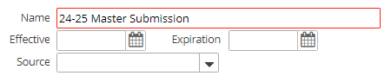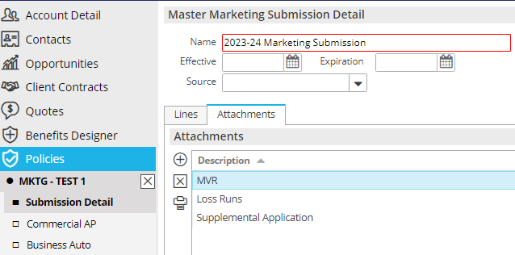

1. When finished, close Submission from the navigation panel (X)

**Add QNEW (New Business) or QREW (Renewal) Activity for each carrier**

1. From the **Policies Marketed** list view, highlight the Master Submission
2. Click the **NEW** button at the top in the blue bar; select **Activity** (or press F9)
3. Go to Full Screen Add



1. 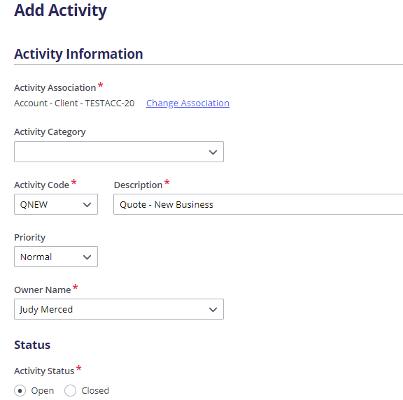Enter activity code: **QNEW** (New Business) or **QREW** (Renew/Rewrite)
2. 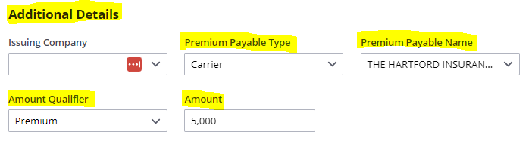Enter Carrier/Broker name and Estimated Premium
3. Leave open; click **Save Activity**
4. Repeat Steps for **each** carrier

**Send Applications to Carriers**

***Save & Submit ACORD Applications***

1. Right click on the Master Marketing Submission created above
2. Select **Review Application**
3. Select the “Master Marketing Submission” radio button; click **Continue**
4. Click the **Organization Contact** tab and verify/update the agency address
5. Click the **Distribution** tab
6. Under **Delivery Options** select **“Attach Without Distributing”**
7. Click **Finish**
8. With the submission highlighted, click **ACCESS >** **Attachments**, **right click** on the ACORD, and select **Send Via Email** if emailing to the underwriter
9. If quoting online, add notes to the specific carrier’s Open QNEW or QREW Activity.

***Attach quote-related documents to QNEW***

Be sure to attach all emails, documents, applications, etc. to **the specific carrier QNEW or QREW activity**

1. Drag & drop onto the **QNEW or QREW** activity
2. Select the **Marketing** Folder
3. Click **Finish** on the **Attach to** screen

**Carrier Responses Received**

1. Record carrier responses by adding NOTES in the **QNEW** **or QREW** activity for the appropriate carrier.
   1. Right click on the carrier’s **QNEW** **or QREW** activity
   2. Select Add Note
   3. Enter detailed note
   4. If carrier responded with a quote, enter the amount of the quote in the amount field on the activity. Use “Premium Quoted” as the amount qualifier.
2. Drag & Drop Carrier emails to the carrier’s **QNEW** **or QREW** Activity. Click **Save Activity**

**Carrier Selected for Binding**

1. When a carrier is selected for **binding**, close **Successful** and add notes
2. **All other QNEW or QREW** activities should be **closed as Unsuccessful**, select a reason, and add notes as to why the carrier declined, or why the quote was rejected

***Move Binding Carrier Submission to Current Policies***

These steps must be followed in order **ONLY FOR THE BINDING CARRIER:**

1. Right click the Master Submission and select **Create Carrier Submission**
   1. Premium Payable = select the binding carrier
   2. Submission Status = Completed
   3. Click **Finish**
2. Right click the Master Submission and select **Update Stage to Entered/Submitted**

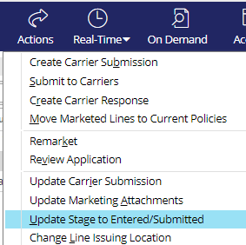

* + Click **Finish**

***The steps above must be done to Generate an Epic Proposal.***

1. Right click the submission and select **Create Carrier Response**
   * Description = Quoted / Bound
   * Date Received = current date
   * Carrier Response = Quote
   * Enter Response Line Premium, carrier commission rate and click Calculate
   * Click **Finish**

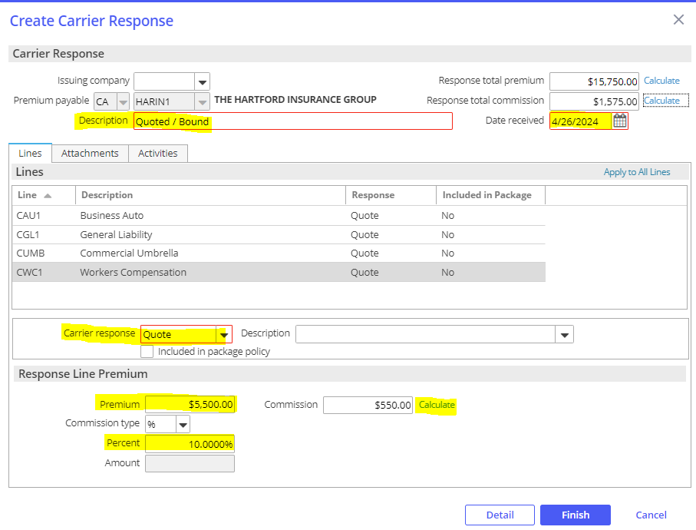

* + On the popup, select Yes Perform Action and select **Move Marketed Lines to Current Policies**

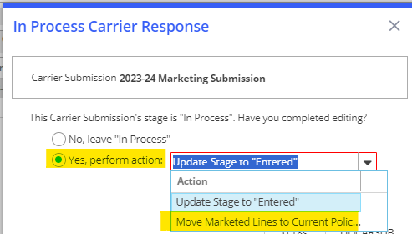

***Policies Tab****:*

1. Select **Add new Policy**
2. Enter Policy Line, Description, Effective & Expiration Dates
3. Update Stage to: Submitted or In Process if policy detail edits are needed
4. Select Contracted policy

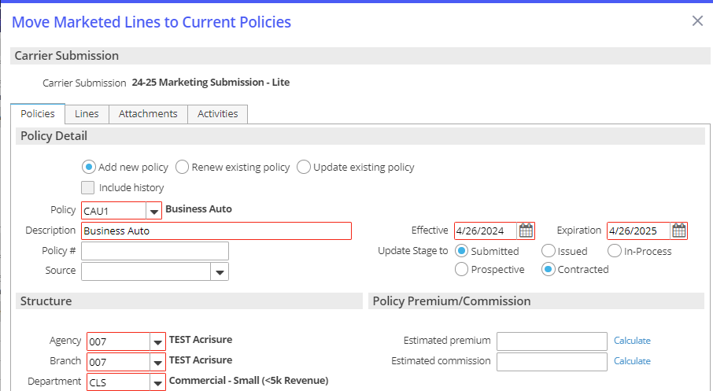

***Lines Tab:***

1. Select the line(s) needing to be added to the new policy, renewal, or existing policy
2. Select **Add to this policy** - Adds the line to the policy added under the Policies tab

* Keep in mind, the choices made here affect only the highlighted line
* Use **Apply to All Lines** if the choices apply to all lines and not just the highlighted line.

1. Under the LINE tab, select Status = NEW; enter Issuing Co (writing co); enter carrier commission rate

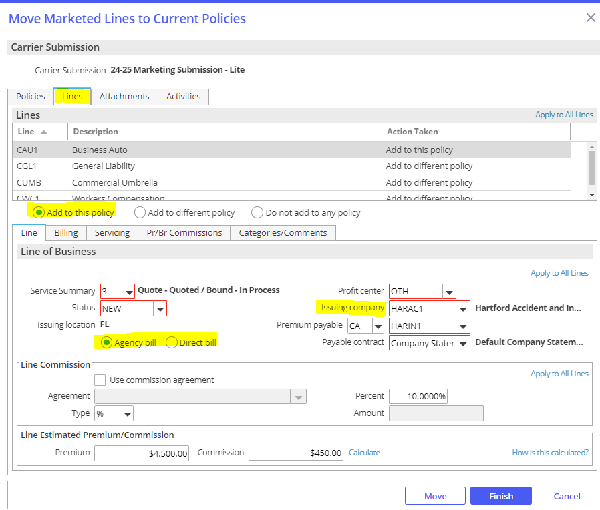

Click the **SERVICING** tab – verify the employees in each servicing role

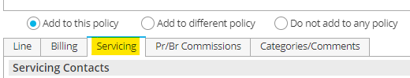

1. Click the PR/BR COMMISSIONS tab

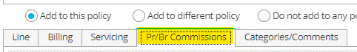

* + Click the **ADD** button to add the producer who will be paid commission on this policy
  + Producer Commission will default
  + Production credit should be 100%

1. When finished, click **MOVE**

* Update Submission status to Completed; click **Finish**

1. **BND1** Activity – Bind Policy via Master Marketing
   * Leave open for receipt of policy
   * Add Notes
2. Change Policy view from MARKETED to CURRENT

**Policy Received from Carrier**

Follow the Policy Received from Carrier step in the New Client Workflow

## JA.2 Marketing Module (Full Version)

### Add Master Marketing Submission

|  |
| --- |
| 1. Click Policy from Client’s account 2. Change policy view from Current to Marketed 3. Click the ADD button 4. Enter a name for the Submission (i.e., Master Submission 2017-2018) 5. Enter required information (Department & type of business) 6. Add policies to the submission by clicking the **ADD** button under Policies to Market 7. **Add New Line**—Create new policy(ies) for marketing 8. **Add Existing Line—**Select from existing policies. Check all policies you want to market. **Include ALL lines of business you wish to market whether you send to a particular carrier or not.** 9. Click DETAIL 10. **Activity** = **AMMK -**Defaults Open for 3 days; click Finish 11. Enter policy detail by clicking each line in the navigation panel and completing each of the screens   When finished, close Submission from the navigation panel (X) |

### Create Carrier Submission

|  |
| --- |
| 1. Select the appropriate Master Marketing Submission 2. Click **ACTIONS** > **Create Carrier Submission** 3. Enter the PPE (Premium Payable) Carrier (CA) or Broker (BR) name 4. Update carrier submission description 5. Check each line to submit to the specific carrier 6. Enter the requested premium/commission (if desired) 7. Click the Attachments tab  * Uncheck attachments that are not needed for this carrier * Click the ADD button to attach additional documents, if needed  1. Click the ADD button to add additional carriers 2. Click Finish |

### Submit to Carriers

|  |
| --- |
| 1. Select the appropriate master marketing submission 2. Click **ACTIONS** > **Submit to Carriers** 3. Click Continue 4. Create one activity per Carrier Submission 5. Place a checkmark beside each carrier you want to send a submission to 6. Highlight the first carrier and complete all tabs for that carrier 7. Review attachments and ADD additional attachments if needed 8. Distribution—select Print, Email or Fax and complete the details 9. Highlight the next carrier (if applicable) and complete all tabs as above 10. Preview if desired; Click Finish 11. **Activity** = **SCAS** defaults to open for 3 weeks; click Finish |

### Create Carrier Response

|  |
| --- |
| 1. Select the appropriate Master Marketing Submission 2. Click **ACTIONS** > **Create Carrier Response** 3. Enter a Description for the Response (i.e., Quoted $1,000; declined due to claims, etc.) 4. Enter Date Received 5. Click the Dropdown for Carrier Response and select Decline, Not Received, or Quote. 6. If you submitted multiple lines and the carrier response applies to all lines, click “Apply to All Lines” in the gray bar, right 7. Click Detail 8. Update policy lines as needed 9. Close policy from the Navigation Panel (X) 10. If quoted, update stage: “Yes Perform Action” - choose **Update Stage to Entered** if still waiting on other carrier responses; **or Move Marketed Lines to Current** if the client has accepted carrier’s quote. |

### Attach Quote-Related Documents to SCAS Activity

|  |
| --- |
| 1. Be sure to attach all emails, documents, applications, etc. to **the specific carrier SCAS activity** 2. Drag & drop onto the **SCAS** activity 3. Select the **Marketing** Folder 4. Click Finish on the **Attach to** screen |

### Bind/Accept Quote

|  |
| --- |
| 1. When a carrier is selected for binding, leave that carrier’s **SCAS** activity Open until you receive the policy dec from the carrier 2. Close All other **SCAS** activities as Unsuccessful and select reason from the dropdown list 3. Add notes as to why not binding with that specific carrier. |

### Move Marketed Lines to Current Policies

|  |
| --- |
| 1. If you chose “Move Marketed Lines to Current” in STEP 3, continue to the Policies tab (below); otherwise, highlight the submission you are moving, and click **ACTIONS > Move Marketed Lines to Current**  * ***Policies Tab*:** * Select Add new Policy if this is a new policy/new business * Select Renew Existing Policy if you created the Marketing Submission from a Renewal * Select Update Existing Policy if you are adding policy lines to an existing policy. * Enter Policy Line, Description, Effective & Expiration Dates * Update Stage to: Submitted, Issued, or In Process * Select Prospective or Contracted policy * ***Lines Tab*:** * Select the lines you want to add to the new policy, renewal, or existing policy * Select:   + Add to this policy - Adds the line to the policy added under the Policies tab   + Add to different policy   + Do not add to any policy * Keep in mind that the choices you make here affect only the line highlighted. * Use Apply to All Lines if the choices apply to all lines and not just the highlighted line. * You have three opportunities to Apply to All Lines in this section * ***Attachments Tab*:**   + If Attachments were added to your Master Marketing Submission, they would show here.   + Check the attachments you need to move with this Policy. * ***Activities Tab:*** * You may close any open activities that exist for this Carrier Submission.  1. When finished, click **MOVE** 2. Update Submission status to **Completed**; click Finish 3. Change Policy view from MARKETED to CURRENT |

## JA.3 Renewal Manager

### Renewal Stages

***Details in the Renewals Manager view are related to the expiring policy.***

|  |  |
| --- | --- |
| **Stage Description** | **How it functions** |
| **Renewal Not Started** | Tied to the Event: **Policy Created** (display policies with this stage in the RM "**0**" days after expiration) |
| **Pre-Renewal In-Process** | Manual - (display policies with this stage in the RM "**30**" days after expiration) |
| **Submitted For Quote** | Manual - (display policies with this stage in the RM "**30**" days after expiration) |
| **Quote Received** | Manual - (display policies with this stage in the RM to "**30**" days after expiration) |
| **Proposed** | Manual - (display policies with this stage in the RM to "**30**" days after expiration) |
| **Renewal In-Process** | Tied to the event: **Policy Renewed** (display policies with this stage in the RM "**30**" days after expiration) |
| **Renewed** | Manual - (display policies with this stage in the RM "**0**" days after expiration) |
| **Did Not Renew** | Tied to the event: **Policy Cancelled** (display policies with this stage in the RM "**0**" days after expiration) |

### Renewal Events

#### Policy Created

This Event is responsible for a new policy as well as a renewed policy to be given the Stage Renewal Not Started. This Stage begins the renewal effort. Policies coming up for renewal will show in the RM, in advance of the renewal date with the Stage Renewal Not Started, according to the time frame assigned to the policy type.

* 120 days for commercial lines policy types
* 60 days for personal lines policy types
* 90 days for employee benefits policy types

#### Policy Renewed

This Event is tied to the Actions>Renew process. When the expiring policy (the current term…the policy currently being worked for renewal) is renewed (via Actions>Renew), the expiring policy (i.e., the current term… the policy currently being worked for renewal) will be given the Stage Renewal In-Process. The renewed policy (i.e., the policy created through the Actions>Renew process) will not show in the RM but will show in the Policy list view (e.g., Policies – Current/Renewed). The renewed policy will be given the Stage Renewal Not Started. This Stage should remain as is until ready to work on the policy renewal the following year. The renewed policy (i.e., the one created via Actions>Renew) will need to be Issued as normal. The Stage given to the expiring policy (i.e., the current term… the policy currently being worked for renewal) will need to be changed, by the user, to Renewed once the renewal policy has been Issued. This Stage, Renewed, will be the final Stage given to the expiring policy in the RM. An expiring policy with the Stage Renewed will drop from the RM view on the expiration day.

#### Policy Cancelled

This Event is tied to the Actions>Cancel>Issued process. The Stage shown on a policy cancelled via the Actions>Cancel>Issued process will be Did Not Renew. Note: if the policy is reinstated, the Stage will automatically revert to the Stage it was assigned before it was cancelled.

### Renewal Manager Workflows

#### View Renewals

1. From **HOME** screen select **Renewals Manager** from Navigation Bar

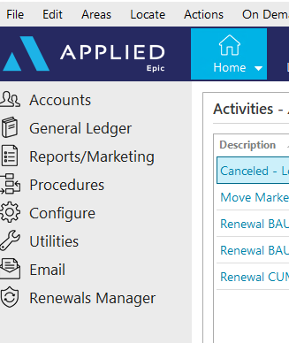

1. Assigned Servicers accounts will be displayed with a **Renewal Not Started** Renewal Stage

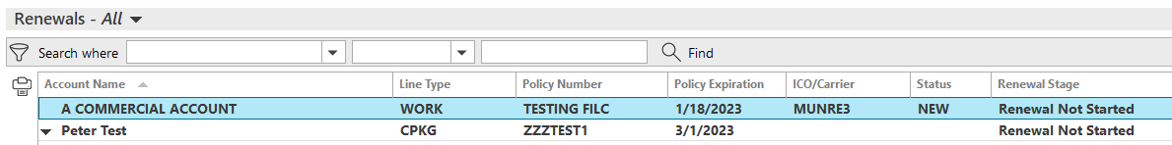

* **Personal Lines**: 60 Days prior to expiration
* **Commercial Lines**: 120 Days prior to expiration
* **Employee Benefits**: 90 Days prior to expiration

1. Click once on renewal to select:



* **Go to Policy** – Moves directly into the policy under the client’s account
* **Renew** – Starts the renewal process from the client’s account
* **Marketing Submission** – Starts a marketing submission from the client’s account
* **Update Renewal Stage** – Allows for manual update to the renewal stage
* **Market Appetite** – Launches IVANS Market Appetite with list of possible markets

#### Renew Policy

1. Select **Renew** then refer to the **Renewal Process**/**Non-Downloaded Policies** section within the Workflows Document



1. Once renewal is started, the Renewal Stage will change to **Renewal In Process**
2. Manually update the stage as needed:

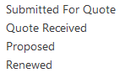

#### Marketing Submission

1. Select **Marketing Submission** then refer to the **Marketing Module** section within the Workflows Document



1. The Renewal Stage will NOT automatically update while working through the Marketing Module. The Renewal Stage must be updated manually by selecting **Update Renewal Stage.**



#### Cancelled/ Non-Renewed Policies

**Cancelled Policies:**

1. Refer to the **Cancel** section within the Workflows Document
2. Once **Cancellation** has been issued, the Renewals Manager Stage will automatically be updated to **DID NOT RENEW** and will drop off the Renewals Manger list

**Non-Renewed policies:**

1. Refer to **Policy Not Renewed** section within the Workflows Document
2. The Renewal Stage will NOT automatically update after the Policy has been manually Non-Renewed. Update the Renewal Stage by selecting **DID NOT RENEW** from **Update Renewal Stage**. This policy will NOT drop off the Renewals Manager list, but will stay for one day AFTER expiration

## JA.4 EPIC Proofs of Insurance

### Auto ID Cards in EPIC

1. Click your Policy
2. From the blue menu bar, click **Actions**
3. Click **Issue Auto ID Card**
4. Verify/Update the tabs:
   1. **Vehicle/Insured:**
5. Highlight the appropriate vehicle
6. Click **Select to Issue**
   1. **Vehicle/Insured, to update form or effective date, i.e. adding a vehicle mid term**
      1. Double click the appropriate vehicle
      2. Verify/Update **Form Description**
      3. Verify/Update **Effective** date
      4. Check **Select to Issue**
      5. Click **Finish**
   2. **State Specific**
   3. **Organization Contact**
   4. **Distribution**:
      1. **Email**: **Send Email from Distribution Manager**
      2. **Fax**: **From Distribution Manager**
      3. **Print**:

a. For a **print preview**, click **Download & Print**

b**.** To **save a copy in Attachments**, select **Print** from the Aia dropdown, click **Finish**. From there you can email directly out of attachments via a right click on your PDF and selecting “Send via Email” to link to your Outlook.

5. Click **Finish**

1. **Activity**, **RED** is required:
   1. **Code, AUID** - #Issued auto ID card
   2. **Description**, best practice is to leave the description that prefills based on your activity, adding in any data if prompted, you can add to the end of the description.
   3. **Who/Owner**
   4. **Follow up/Start**
   5. **Status**, defaults as **Closed, Successful**
   6. **Notes**
   7. Click **Finish**

### Evidence Processing in Epic

#### Add a Master Template

1. Locate client in Epic.
2. From the navigation panel, click **Proofs of Insurance**.
3. From the Proofs of Insurance drop down, click **Evidences**.
4. From Evidence-Property, click **Add (+)**.
5. From the Add Evidence of Insurance, **Type** drop down, select the appropriate Acord form.
6. Enter Title based on needs, examples: 2024.25 Acord 27; 2024.25 Garden City Realty
7. From the Line of Business, Type drop down, select the current Property policy.
8. From the Line of Business, Service summary drop down, select the correct Service summary.
9. To **Copy Additional Interests** from another master evidence template:

1. From Default Additional Interests from other Evidence(s) of Insurance, click **Add (+)**.

1. From the Default Additional Interests window, click the **Default additional interests from** drop down.

1. Select the master template you would like to copy additional interests from.

1. Select each additional interest you would like to copy.

1. Select **Default the additional interests special conditions**, if applicable.

1. Select **Default the additional interests attachments**, if applicable.

1. Click **Finish**.

1. Click **Detail**.

1. From the navigation panel, click each section to enter coverage details, example:

1. **Policy Level Coverages**:  Enter policy level coverage.

1. **Risks/Coverage**: Click **Add (+)** to select location specific coverage.

1. **Special Conditions**: Enter template level special conditions.

1. **Attachments**: Add template level attachments.

1. **Remarks**: Add template level remarks.
2. From the navigation panel, click **X**.

#### Issue an Evidence of Property Insurance

* 1. From the navigation panel, click **Proofs of Insurance**
  2. Click **Evidences**
  3. Click on the appropriate template
  4. From, **Additional Interests**:

**Select an existing Additional Interest**:

* + 1. From Additional Interests, click the appropriate Additional Interest

**Add an Additional Interest**:

1. From Additional Interests, click **Add (+)**
2. **Additional Interest**
3. **Policy Level Coverages**, Use main policy coverages will default
4. **Risk/Coverages**, Use main risk/coverages will default. Uncheck and click Add (+) to pick from Risks/Coverages.
5. **Documents Attached**, additional interest level documents, these will appear each time you issue a COI for the holder.
6. **Additional Interests Details**
7. From the blue menu bar, click **Actions**
8. Click, **Issue Single Additional Interest** to select the highlighted or **Issue Evidence** to select multiple additional interests.
9. Verify/Update:
   1. **Organization Contact**
   2. Verify/Update **Additional Interest Distribution:**
   3. **Download & Print,** to preview.
   4. Click **Finish**
10. Activity, **RED** is required:
11. **Code**, **EVID** – # Issued Evidence of Insurance &PolDesc& &PolEffDate
12. **Description**, best practice is to leave the description that prefills based on your activity, adding in any data if prompted, you can add to the end of the description.
13. **Who/Owner**
14. **Follow up/Start**
15. **Status**, defaults to **Closed**, **Successful**
16. **Notes,** notes regarding conversation with client
17. Click **Finish**

#### Renew an Evidence of Property Insurance

* 1. From the navigation panel, click **Proofs of Insurance**.

* 1. From the Proofs of Insurance drop down, click **Evidences**.

* 1. From Evidence-Property, click the appropriate template to highlight.

* 1. From the menu bar, click **Actions**.

* 1. From the Actions drop down, click **Renew Evidence**.

* 1. Enter Title, example: 2024.25 Acord 27; 2024.25 Garden City Realty

* 1. **Renewal policy**, pick appropriate from drop down
  2. **Service summary**, pick appropriate from drop down

1. Select the appropriate Default boxes:

1. **Description of Operations**: Will pull the existing template level Description of Operations

1. **Special Conditions**: Will pull the existing template level Special Conditions

1. **Additional interests with risks and coverages**: Will pull the existing schedule of Additional interests.

1. **Include inactive additional interests**: Will pull inactive additional interests.

1. **Additional interests special conditions**: Will pull additional interest level special conditions.

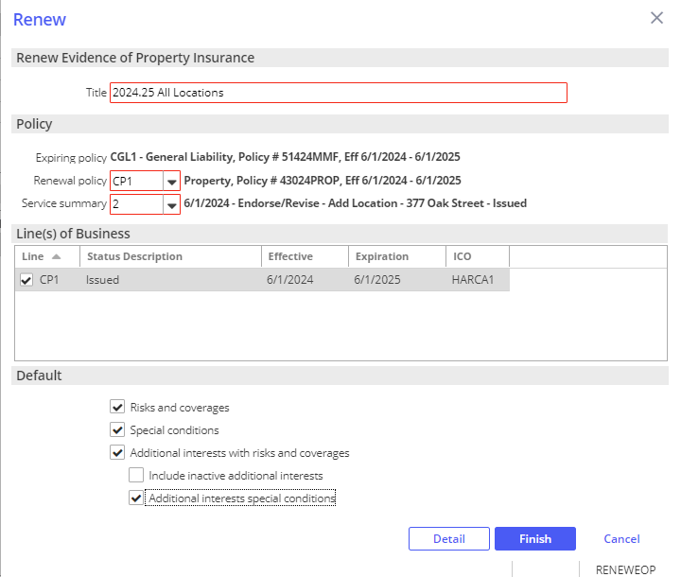

1. Click **Detail**.

1. From the Add an Activity window, add notes if needed, click **Finish** to close the **REVI** activity.

1. From the navigation panel, update the coverage details.

1. From the menu bar, click **Actions**.

1. From the Actions drop down, click **Issue Evidence**.

1. **Organization Contact** Tab, verify agency address and contact information.
2. **Holder Distribution** tab, click **Select All** to renew all holders or select holders as needed, uncheck clients name.

1. **Delivery Options**, select from the Via drop down.

1. To preview COIs before issuing, click **Download and Print**.
2. Click **Finish**.
3. From the Add an Activity window, click **Finish** on the **EVID** activity.
4. A copy of the renewal batch is automatically attached in the client’s Attachments.

### Certificate Processing in Epic

#### Add a Master Template

1. Locate client in Epic.

1. From the navigation panel, click **Proofs of Insurance**.

1. From the Proofs of Insurance drop down, click **Certificates**.

1. From Certificates-Liability, click **Add (+)**.

1. From Add Certificate, Type drop down, select **Acord Certificate of Liability Insurance**.

1. Enter Title, example: 2024.25 GL, Auto, Umbrella.

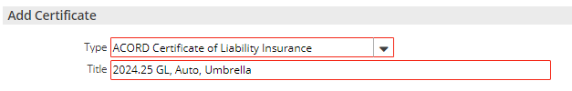

1. Click **Detail**.

1. Verify Named Insured + Address, this will prefill on all COIs.

1. Add applicable line of business, example:

1. From the navigation panel, Liability drop down, click **General Liability**.

1. From Available Templates, click **Add (+)**.

1. From the Line of business drop down, select the current General Liability policy.

1. From the Service summary drop down, select the correct Service summary.

1. Enter **Description**, example: 2024.25 General Liability.

1. Check **Default template**, to default coverage for each holder.
2. From the Type of Insurance/Limits tab, limits will populate based on the policy details entered in Epic.

1. If applicable, for an Acord 855 NY Construction COI Addendum option at the holder level, click **Acord 855 NY tab**.

1. From the Acord 855 NY, enter data as needed.

1. Repeat steps A-G as needed to add Auto, Excess/Umbrella, Workers Compensation + Other.

**Notes:**

**Available Templates:** Multiple templates can be added, and each template can include coverage and limit information applicable to the circumstance.

**Include history:** This will bring in all expired policies if you need to include historical policy details into the certificate.

**Include all lines of business:** This will bring in any other active lines of business.

**Line of business:** Select the appropriate policy.

**Service summary:** Select the appropriate Service Summary Row for the line of business, as the coverage and limits are based on the Service Summary Row.

**Description:** Enter title, when multiple templates are being utilized at the policy level be descriptive so you can differentiate.

**Default template:** By checking this, you will default this line of business to as holders are added.

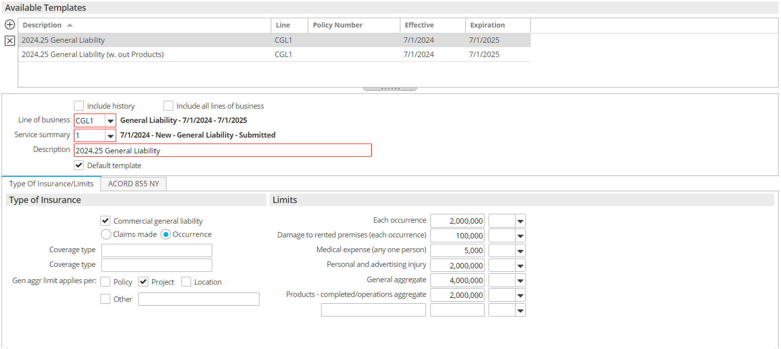

**Navigation panel, Description of Operations:** This will appear on every holder’s certificate that you use this template for, this is a template level Description of Operations.

**Navigation panel, Attachments:** These will appear on every holder’s certificate that you use this template for, this is a template level Attachment.

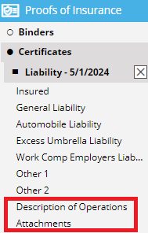

#### Add a Certificate Holder

1. From the navigation panel, click **Proofs of Insurance**.

1. From the Proofs of Insurance drop down, click **Certificates**.

1. From Certificates-Liability, double click your template.

1. From the navigation panel, click **Holders**.

1. To **Copy Holders** from another master certificate template:

1. Click, **Copy from Another Certificate**.

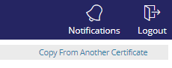

1. From the Default Holders window, click the **Default holders from** drop down.

1. Select the master template you would like top copy holders from.

1. Select each holder you would like to copy.

1. Select **Default the Holders description of operations**, if applicable.

1. Select, **Default the holders attachments**, if applicable.

1. Click **Finish**.

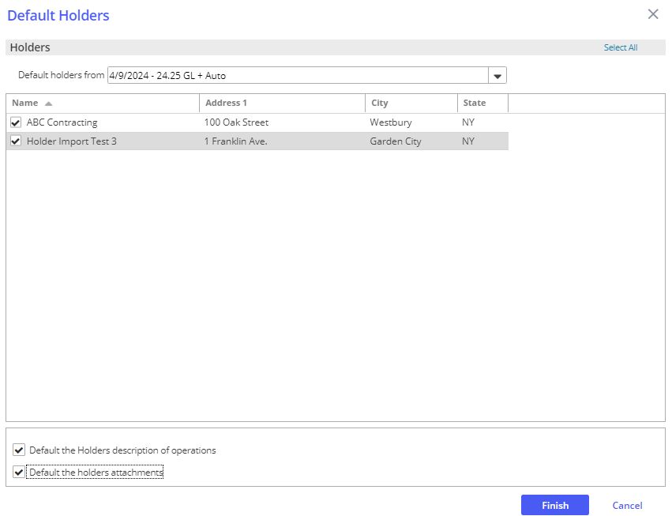

1. To add a **New Holder**:

1. From the navigation panel, click **Holders**.
2. From Holders, click **Add (+)**.

1. **Holder/Templates tab**:

1. **Holder**: Enter Name, Address and distribution method via the Distribute via drop down.

1. **Templates for this Holder**: Templates will default based on master template selection. Should template need to be changed, do so via the line of business drop downs.

1. **Include Acord 855 NY**: If you included an Acord 855 NY at the policy level, check this box to include a copy at the holder level. When you issue the COI the form will be included in it's original state.

1. **Email Recipients**: This will only be available if you select Email in the Distribute via drop down in the Holder section. This email address will prefill in the Delivery Options if you select to send via Email during issuance.

1. **Description of Operations tab**:

1. Enter the enter holder specific description of operations.  If you add language to the summary field, be sure to check the box to Print Holder Summary so it will appear on the certificate.  There is also room below this field to add more detailed information if needed.

1. **Documents Attached tab**:

1. Add attachments at the holder level, these will appear each time you issue a COI for the holder.

1. **Holder Details Tab**:

1. Check the applicable Additional Insured On + Subrogation Waiver On boxes.

1. Verify the Named Insured + Address. If you need to add a different Named Insured, click the magnifying glass to select the appropriate Named Insured from the **Contacts** area of the client’s account.

1. **Acord 855 NY**:

1. If you have an Acord 855 NY set up for your template and/or you need an Acord 855 NY specific to the holder and have checked off the Include Acord 855 NY box at the Holder/Templates tab, you can enter holder specific data.

1. From the navigation panel, click **X**.

#### Issue a Certificate

1. From the navigation panel, click **Proofs of Insurance**.

1. From the Proofs of Insurance drop down, click **Certificates**.

1. From Certificates-Liability, click the appropriate template to highlight.

1. From Holders, click appropriate holder to highlight.

1. From the menu bar, click **Actions**.

1. From the Actions drop down, click **Issue Certificate** for multiple holders, **Issue Single Holder** for one holder.

1. Organization Contact Tab, verify agency address and contact information.

1. Holder Distribution tab:

1. **Distribute to**: Uncheck the client name.
2. Check the Holder and click on the holder to highlight. The information showing beneath the Distribute To list pertains to the highlighted item. If issuing multiple holders, check off the additional holders, repeat as necessary.
3. **Scanned Signature**: Select from the drop down, this is a required field.
4. **Delivery Options**:  Select from the Via drop down. If emailing, subject is a required field.  You can also cc and bcc the certificate.
5. To preview COI before issuing, click **Download and Print**.
6. Click **Finish**.
7. From the Add an Activity window, click **Finish** on the **CERT** activity.
8. A copy of the COI is automatically attached in the client’s Attachments.

#### Renew a Certificate

1. From the navigation panel, click **Proofs of Insurance**.

1. From the Proofs of Insurance drop down, click **Certificates**.

1. From Certificates-Liability, click the appropriate template to highlight.

1. From the menu bar, click **Actions**.

1. From the Actions drop down, click **Renew Certificate**.

1. Enter Title, example: 2024.25 GL, Auto, Umbrella.

1. Select the appropriate Default boxes:

* 1. **Description of Operations**: Will pull the existing template level Description of Operations

* 1. **Attachments**: Will pull the existing template level Attachments.

* 1. **Holders**: Will pull the existing schedule of holders.

1. **Include inactive holders**: Will pull inactive holders.

1. **Holders Description of Operations**: Will pull holder level Description of Operations.

1. **Holders attachments**: Will pull holder level attachments.

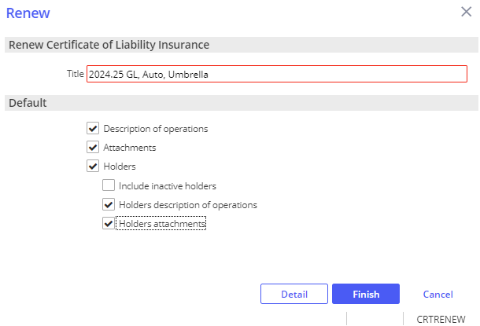

1. Click **Detail**.

1. From the Add an Activity window, add notes if needed, click **Finish** to close the **RCER** activity.

1. From the navigation panel, update the coverage details.

1. From the menu bar, click **Actions**.

1. From the Actions drop down, click **Issue Certificate**.

1. Organization Contact Tab, verify agency address and contact information.
2. Holder Distribution tab, click **Select All** to renew all holders or select holders as needed, uncheck clients name.

1. Delivery Options, select from the Via drop down.

1. To preview COIs before issuing, click **Download and Print**.
2. Click **Finish**.
3. From the Add an Activity window, click **Finish** on the **CERT** activity.
4. A copy of the renewal batch is automatically attached in the client’s Attachments.

### EPIC Binder

1. Locate client in Epic
2. From the navigation panel, click **Proofs of Insurance**
3. Click **Binders**
4. Click **Add (+)**
5. Add **Description**
6. Highlight the appropriate policy
7. Click **Detail**
8. From the navigation panel, review/update binder details

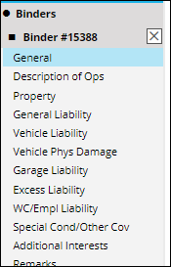

1. From the blue menu bar, click **Actions**
2. Click **Issue Binder**
3. Verify/Update, **RED** is required:
   1. **Organization Contact**
   2. **Additional Interest Distribution**
   3. **Download & Print**, to print preview
   4. Click **Finish**
4. **Activity**, **RED** is required:
   1. **Code**, BIND - # Issued binder &PolDesc& &PolEffDate &Policy#&
   2. **Description**, best practice is to leave the description that prefills based on your activity, adding in any data if prompted, you can add to the end of the description.
   3. **Who/Owner**
   4. **Follow up/Start**
   5. **Status**, defaults as **Open** to follow up as needed
   6. **Notes**
   7. Click **Finish**

#### Extend Binder

1. Locate client in Epic
2. From the navigation panel, click **Proofs of Insurance**
3. Click **Binders**
4. Highlight the appropriate Binder
5. From the blue menu bar, click **Actions**
6. Click **Extend Binder**
7. Verify/Update**, RED** is required**:** 
   1. **Expiration**, defaults to 30 days, select time
   2. **Description**
   3. Click **Finish**

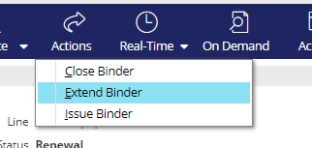

1. From the blue menu bar, click **Actions**
2. Click **Issue Binder**
3. Verify/Update, **RED** is required:
   1. **Organization Contact**
   2. **Additional Interest Distribution**
   3. **Download & Print**, to print preview
   4. Click **Finish**
4. **Activity**, **RED** is required:
   1. **Code**, BIND - # Issued binder &PolDesc& &PolEffDate &Policy#&
   2. **Description**, best practice is to leave the description that prefills based on your activity, adding in any data if prompted, you can add to the end of the description.
   3. **Who/Owner**
   4. **Follow up/Start**
   5. **Status**, defaults as **Open** to follow up as needed
   6. **Notes**
   7. Click **Finish**

#### Close Binder (Policy/Endorsement Received)

1. Locate client in Epic
2. From the navigation panel, click **Proofs of Insurance**
3. Click **Binders**
4. Highlight the appropriate Binder
5. From the blue menu bar, click **Actions**
6. Click **Close Binder**

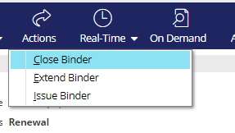

1. Verify/Update, **RED** is required:
   1. **Closing Details**
2. **Closing description**
3. **Disposition**
   1. **Close Open Activities,** if applicable
   2. Click **Finish**

## JA.5 DocuSign Integration

**From Attachments in the Client’s account**:

1. Right-click the attachment and select **Send to eSignature**

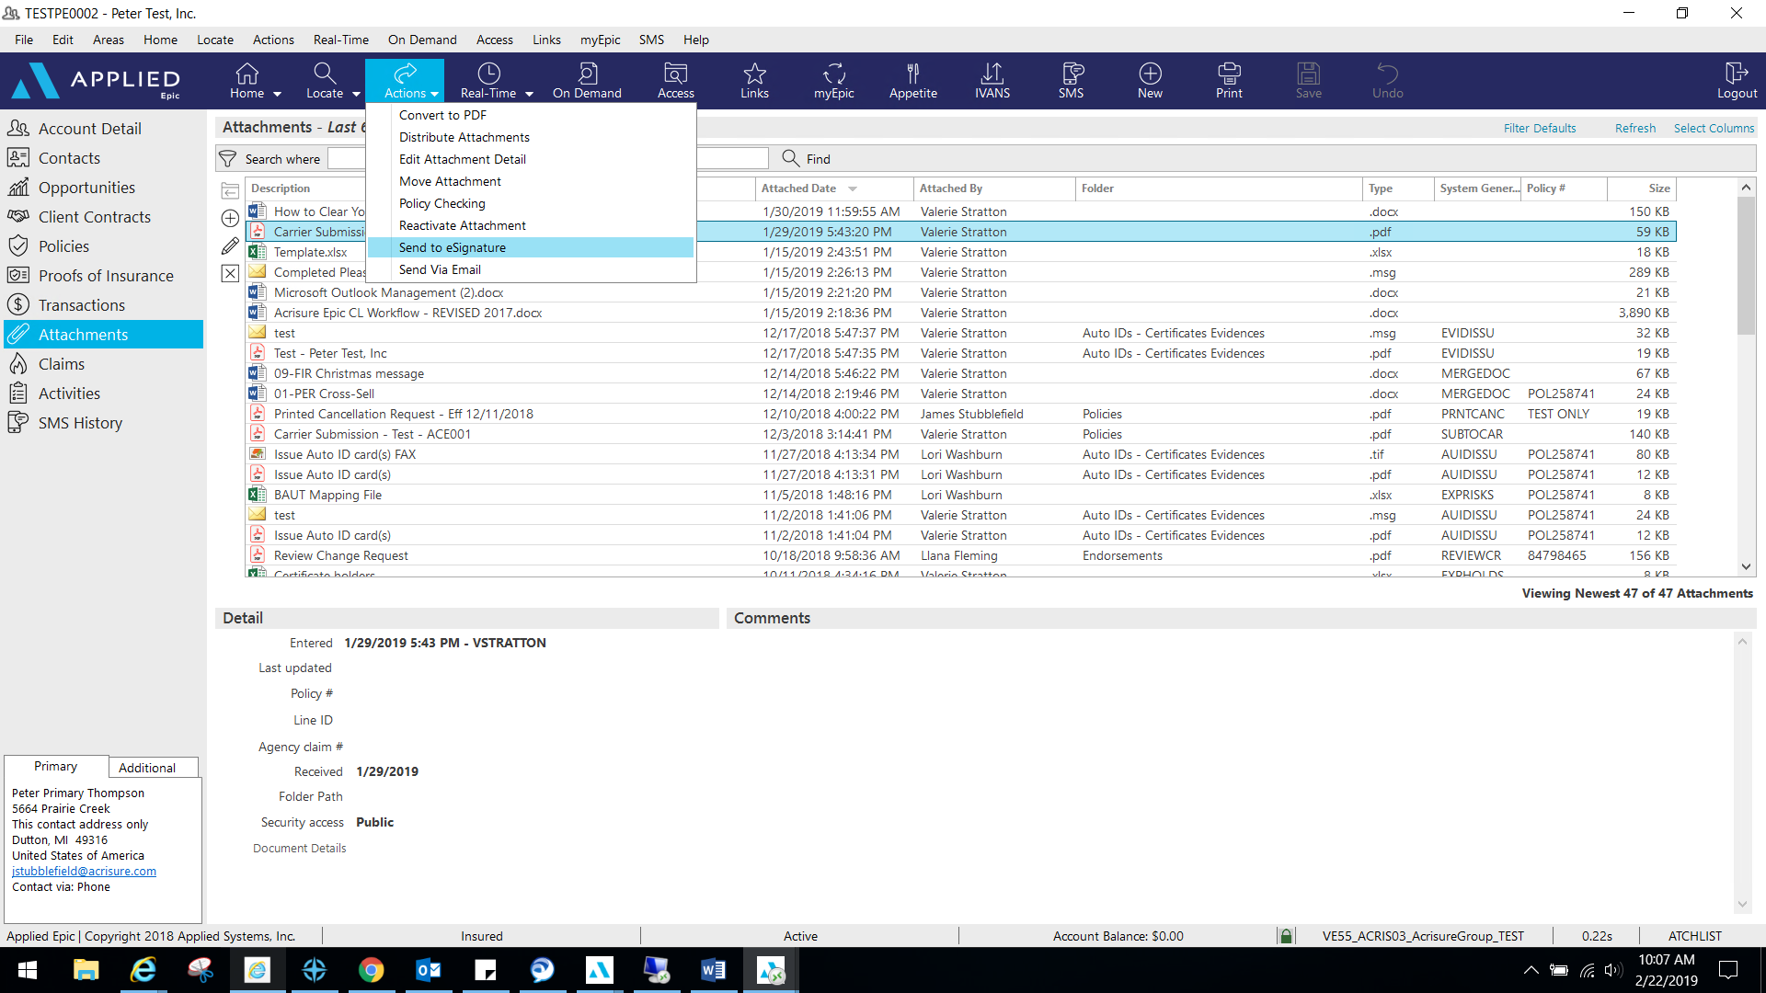

1. 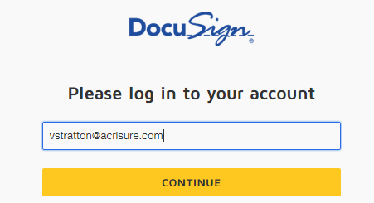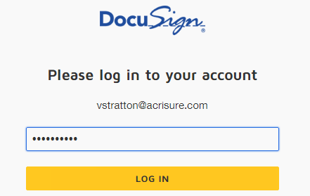Log into **DocuSign** using your email address and password.
2. Allow DocuSign permission to integrate with Epic.

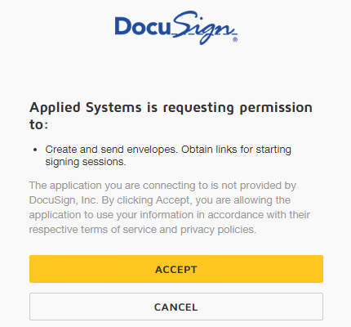

1. Select an Epic Contact; click the TO button

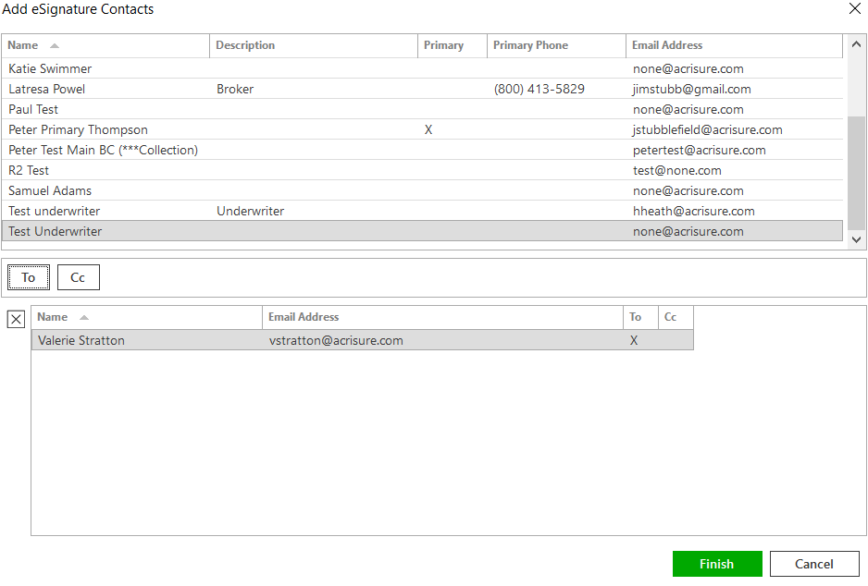

1. Please wait while Epic directs the document to DocuSign for signatures fields.
2. Add appropriate fields for signature, date, text, etc. by dragging and dropping onto the document.

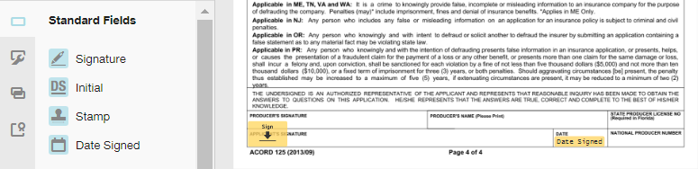

1. If using a template, remove the extra recipient. **Actions>Edit Recipient**.  
   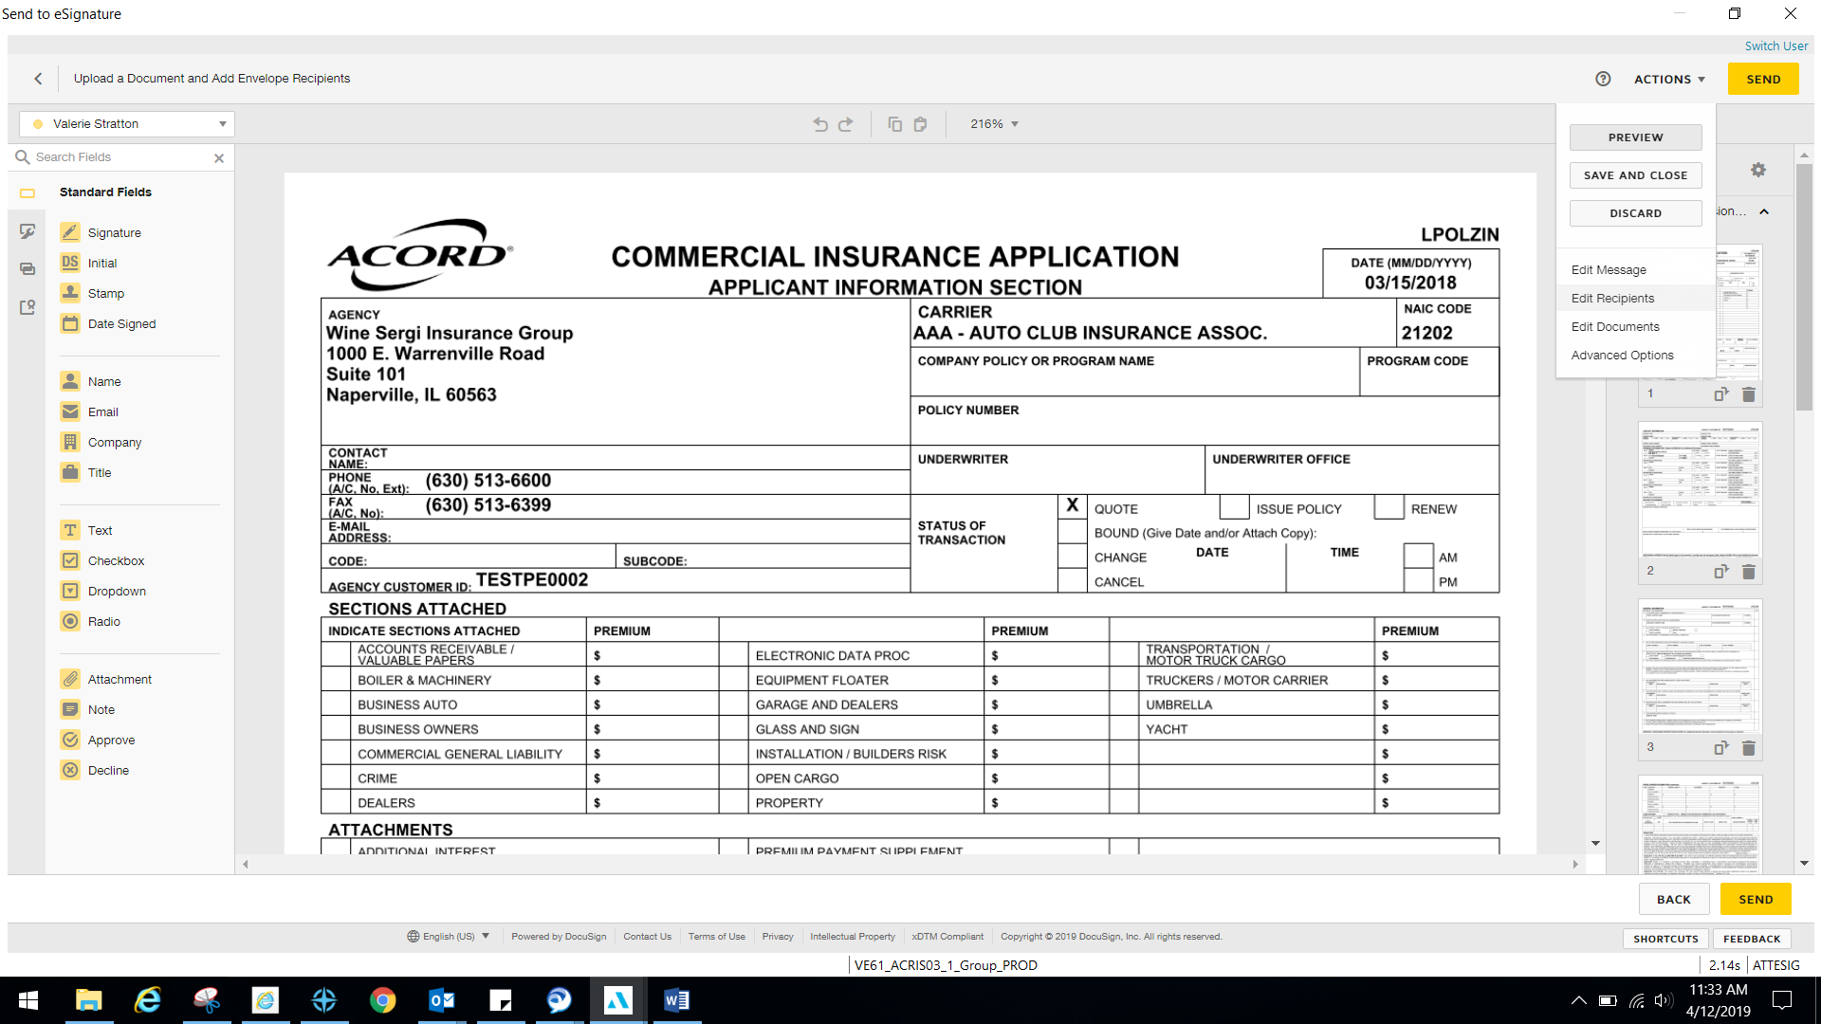
2. Once finished, select **Actions>Edit Message**.

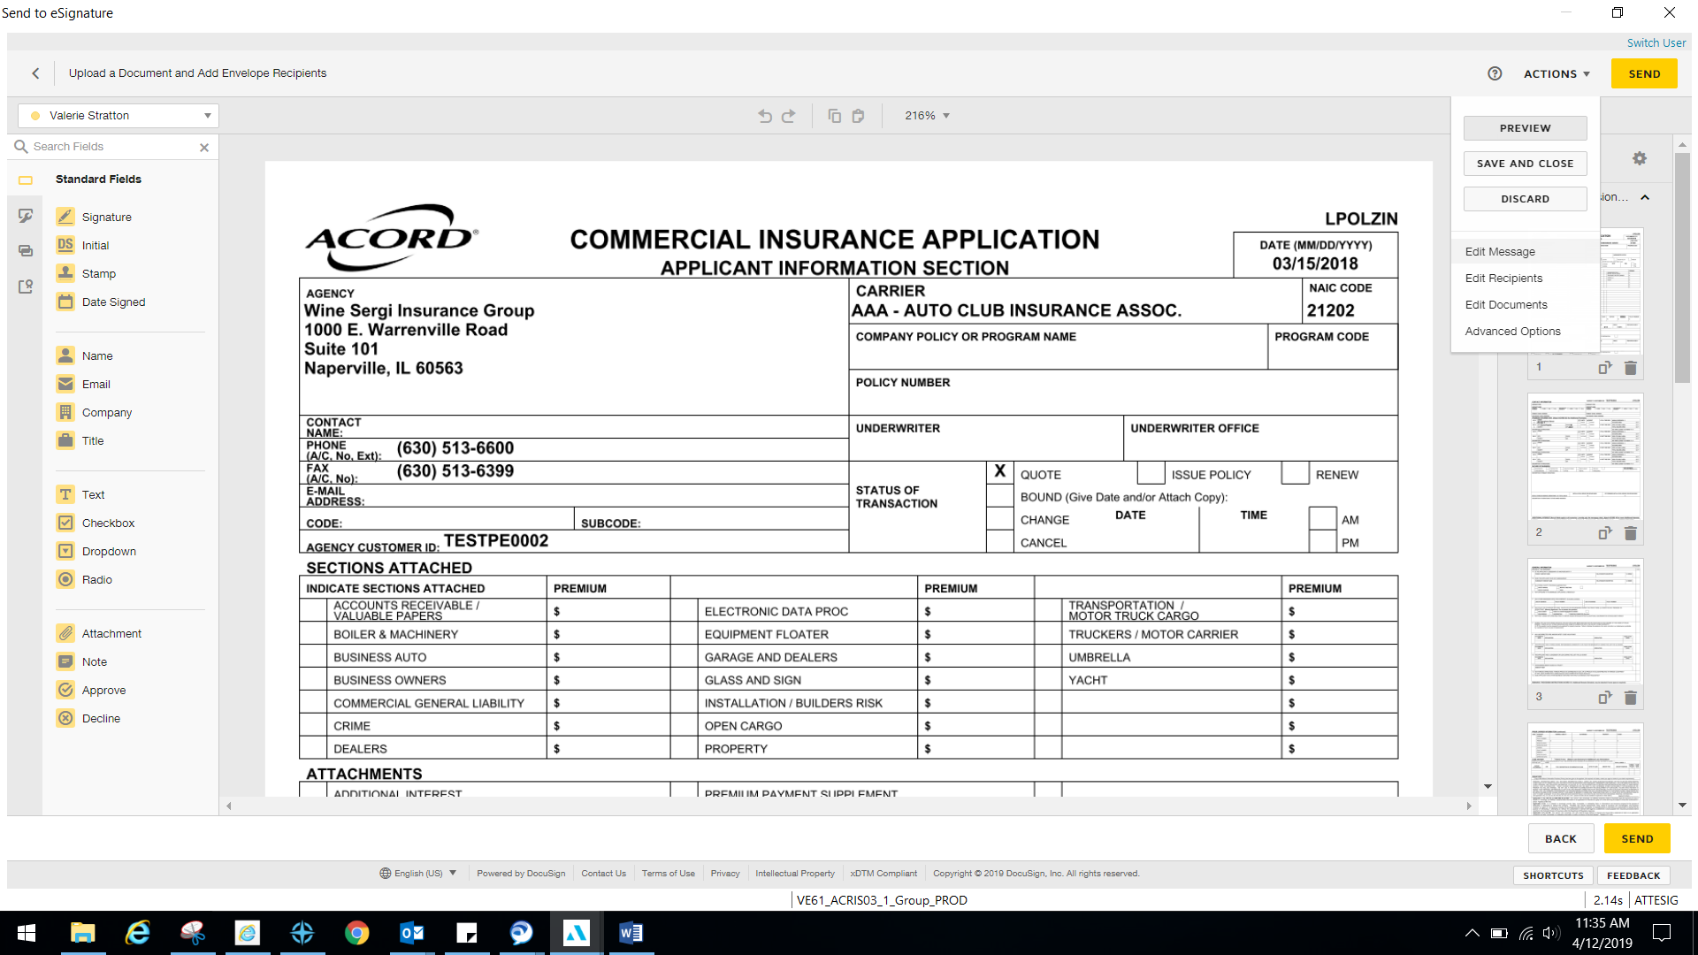

1. Edit the email subject line and personalized message to client; select **Done**.

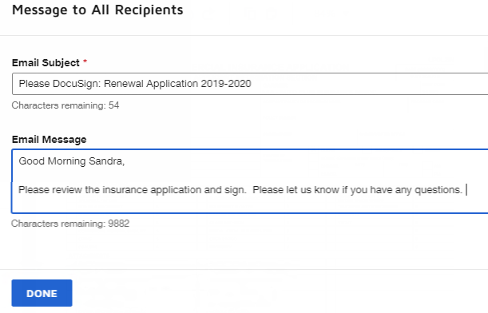

1. Select **Send** in the top right or bottom right corner when finished.

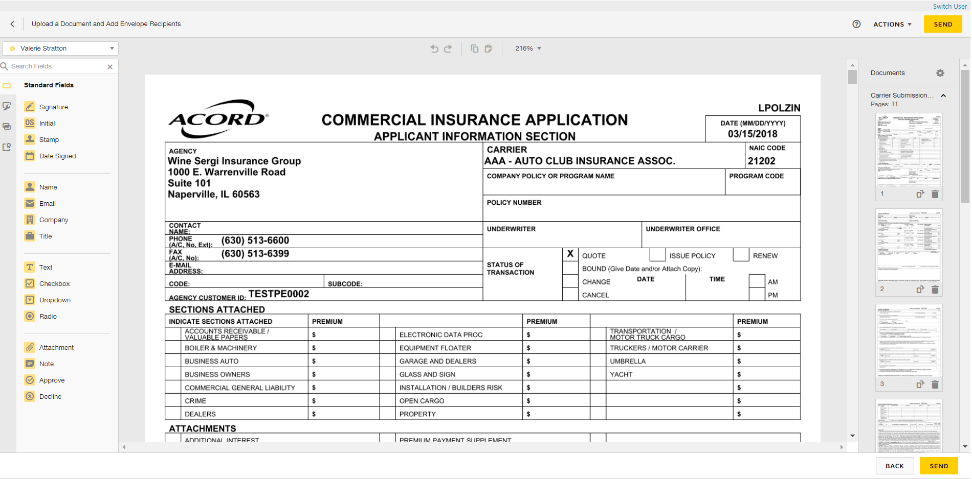

1. DocuSign will redirect you to sign into your account to manage your envelopes. **Close out** when finished.
2. **ESIG** will be the automatic activity generated once finished and will automatically remain open for follow up. Close **ESIG** as successful if there is another open activity related to this process.

## JA.6 CSR24 Workflow

|  |
| --- |
| Access to the CSR24 Workflow Manual can be found here:  [CSR24 Workflow Manual v4.17.25.docx](https://acrisure.sharepoint.com/:w:/r/sites/AcriWorld/Shared%20Documents/Enterprise_Solutions_Center/Platforms/Mid_Atlantic/Epic,%20CSR24%20%26%20Indio%20Resources/CSR24%20Training%20Videos%20%26%20Documents/CSR24%20Workflow%20Manual%20v4.17.25.docx?d=wd4e0336dc40846a59034f445016df337&csf=1&web=1&e=kk7cJX) |

## JA.7 Job Aid – Statement of Values

* + - 1. From the Client’s Account, Click the **Policies** from the left navigation panel
      2. Highlight the Property Policy
* *Policy HAS to be ‘In Process’ – if Policy is NOT ‘In Process’ follow* *internal endorsement* *and select* ***CHGI*** *activity code)*
  + - 1. Double Click the Property Policy
      2. From the Navigational Panel, click the Commercial AP and select Premises

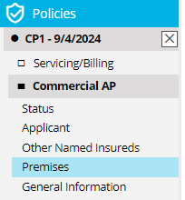

* + - 1. In the Premises area, click the plus sign to add a new location

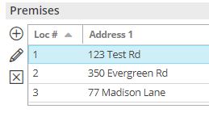

* + - 1. In the popup box, check the box for Blanket and in the address field, type “BLANKET”

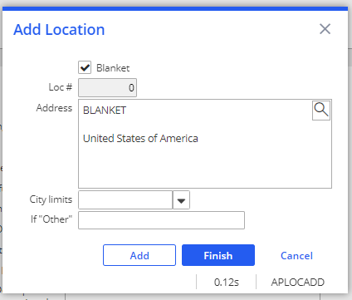

* + - 1. Click **Finish**
      2. In the left Navigational Panel, double click the Property Line
      3. Click **Premises** in the Navigational Panel
      4. Click the **+** under **Premises** to add the **Location 0**
      5. **Location 0** – Blanket will appear. Check the Box.
      6. Click **Finish**

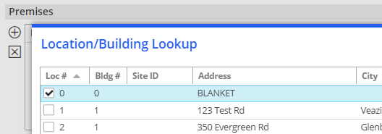

### Update Subjects of Insurance

* + - 1. From the Navigational Panel, click Subjects under the Property Line
      2. Enter all data for each location, i.e. Subject of Insurance, Description, Amount, Valuation, etc.
      3. Be sure to add a Cause of Loss and update the Coinsurance %, otherwise the values for each will show as $0 on Statement of Value.



* + - 1. Repeat for each location; highlight the location and fill in the details for the highlighted location at the bottom.

### Prepare Statement of Values

1. Click **Statement of Values** in the Navigation Panel
2. Click the plus sign under the Statement of Values Schedule tab
3. At the top, under the Statement of Values – ACORD 139 section, fill in all relevant information, i.e. Headquarters address, other coverages like earthquake and flood, coinsurance percent, applicable cause of loss and total value. ***NOTE: You will need to manually total the property values and enter the total in the Total Value Field***
4. Select all locations to be included in the Statement, check the box to include all property premises if applicable, then click **FINISH**



### Print Statement of Values

Click the PRINT button from the top blue options bar and select Statement of Values

Click the Distribution tab to select the distribution options (Print, Email, Fax) and enter all details

Click Download & Print to view the document before distributing Click FINISH

## JA.8 Import and Export Risks

|  |
| --- |
| Import/Export can be performed for the following:   * Locations * Drivers * Named Insureds * Vehicles * Scheduled Equipment |

### STEP 1: Create a Mapping File

|  |
| --- |
| A correctly formatted mapping file is needed to ensure that data imports into the correct fields in Epic. Before importing, create a blank mapping file (spreadsheet)   1. Highlight appropriate policy 2. Click ACTIONS > Export Risks 3. Select Type of Import – drivers, vehicles, etc. 4. Select Mapping File 5. Enter a file name 6. Check “Disable Delivery Options” 7. Check “Send as Blank Template”   A screenshot of a computer  Description automatically generated   1. Click Continue 2. Click Export; Click YES 3. Click Attachments and locate the mapping file. The mapping file can then be used to paste details into a file for the initial import, proceed to next step. |

### STEP 2: Enter data on the Mapping File

|  |
| --- |
| **Template file MUST remain as is. Do not delete any columns or the Import will not work.**   1. Copy and paste the information in each column. If there is no data for a particular column, leave it blank. 2. Click File > Save As and rename the Import File saving it to your Desktop |

### Exporting Risks out of Epic

|  |
| --- |
| For risks that are already in Epic, use the export risk function to generate a spreadsheet that the client can update at renewal. Those risks can then be imported back into Epic.     1. Highlight appropriate policy 2. Click ACTIONS > Export Risks 3. Select Type of Import – drivers, vehicles, etc. 4. Select Mapping File 5. Enter a file name – ex. 2024 Driver List 6. Check “Disable Delivery Options” or complete the email information to deliver out of Epic to the client 7. Click Continue 8. The next screen will show all risks to be exported, if that list looks correct, click Export > then click YES 9. The file will be in the attachments. Email to client for review and update. Completed spreadsheet should be saved on your desktop for importing into Epic |

### Importing Risks into Epic

|  |
| --- |
| Policy status MUST be “In Process” in order for Import Risks to work. If the policy is not “In Process”, click **ACTIONS** > Endorse/Revise Existing Lines and choose the **CHGI** (Internal Policy Change) activity code. After the Import is complete, **ACTIONS** > Issue/Not Issue Endorsement and select Issue.   1. Highlight appropriate policy 2. Click ACTIONS > Import Risks 3. Click the ADD button to add the source file 4. Select Risk Type 5. Select an Importing Option:    1. Import & Update – items with no match will be added    2. Import & Replace – imported list will replace ALL existing items. Coverage information will be lost    3. Import, Update & Remove – items with no match will have the option to be deleted from the policy 6. Select File to Import – click the magnifying glass to locate the file you created in Step 2. 7. Choose “Existing File” if the file is located outside of Epic (i.e., Desktop); click Continue 8. Browse, select file, click Open 9. Change Description if needed 10. Click **Finish** 11. Click **PROCESS**   A screenshot of a computer  Description automatically generated   1. A close up of a screen     Description automatically generatedPay attention to the **STATUS**; click Refresh. 2. When status = **Processed**, click CREATE 3. Pay attention to the STATUS; click Refresh 4. When status = **Created**, click PREVIEW 5. Import list will display 6. Click **IMPORT** 7. Click **YES** 8. Pay attention to Status; click Refresh 9. When import file disappears, the import was successful 10. Close window (red X top right) 11. Double click policy to view imported data 12. Close policy in Navigation Panel (gray X) 13. Select “Yes Perform Action” and choose “Issue/Not Issue Endorsement” 14. Click Finish |

### Import Errors

|  |
| --- |
| Sometimes data does not import correctly. When this happens, the following messages appears. Follow the steps to review and update the errors.  A screenshot of a computer error  Description automatically generated  Epic will save a separate Excel file containing all the rows that failed.   1. Locate the Error File in Attachments 2. Fix the issues 3. File > Save As and save the updated file to your Desktop 4. Run the Import again |

## JA.8 Creating a Proposal or Summary in Epic

### General Information

|  |
| --- |
| Epic has been configured with templates to allow users to generate Platform branded Proposal and Summary that can be used to present to clients when marketing coverage for new or renewal business. The Summary template is accessed using On Demand>Proposal – Do not use On Demand>Summary of Insurance.    **The following are highlights and pointers to consider:**   * The same proposal group works from either the Current/Future lines or the Marketed lines (at the carrier response stage) * Each line of business is configured to pull the following four (4) areas from the Epic policy details into the Line of Business page on the Proposal:   + Additional Coverages   + Forms & Endorsements   + Remarks (only when the Print on form is checked)   + Additional Interest * When using the Summary Group, users will have to associate the Line of business to both the Premium Summary pages and the detail pages for each selected policy. This will ensure that the policies will appear on the premium summary page as well as the policy detail pages.      * Remember to enable Macros when the Word document generates as this is how the data merges into the document. * The overall formatting of each page of the Proposal and Summary templates has been designed to meet the legal specifications of Acrisure and to meet general needs of most of the users. The word document will need to be reviewed carefully as some data may need to be manually updated. Tables and data fields with no information should be updated or deleted and spacing should be adjusted to provide a professional look and feel. |

### How to Generate a Proposal

|  |
| --- |
| 1. Within the Client Account navigate to the Policies tab.  2. Click on a policy (or package header)   * 1. If creating a proposal for Marketed, change the view from Current/Renew to Marketed and then select the Submission.   3. On the Option Bar/Menu (Blue Options Bar) click **On Demand>Proposal**.  **Refer to the screen shot below and the corresponding numbers with the following steps:**    See Notes  1. Add/Remove the policies that will need to be included in the proposal.   * 1. Click on the **ADD** button and choose from either:   2. the available current/renewed policies, if generating from the current/renew policies view   3. the available lines being in the marketing submission, if generating from the marketing area   * You do not need to reposition the LOBs on the top half of the proposal box.  2. Pick the Proposal Group. Choose the option that best suits your needs.   * 1. 1. Acrisure Standard Proposal   2. 1. CL Acrisure Summary of Insurance   3. 1. PL Acrisure Summary of Insurance   3. The Proposal Templates/Proposal Documents box will display all the preselected pages available based on the selected Proposal Group. This list must be reviewed, and pages deleted or rearranged based on guidelines determined by your leadership.   * 1. You must have a cover page and it must be in the **top position**.   2. Associate a Line of Business to the Location Summary page to pull premises data.   4. Individual Contacts are from the Account Contacts tab and will default with the Primary contact. added here will pull through to the Authorized Persons page.  **Notes:**  1. Before pressing Finish, you can add/move/delete pages, using the buttons on the left.  2. If you have multiple LOB of the same type, extras will drop to the bottom of the list. Be sure to reorder them before pressing Finish.  3. The premium summary page **must** appear **after** all the LOBs. Note: after merging, it can be moved.  4. LOBs without an associated Line will be suppressed by default. Uncheck the box next to Suppress blank templates to bring in the page even if there is not a LOB connected yet (e.g. you want to offer Cyber but it is not included on your account yet). |